CHAPTER ONE

INTRODUCTION
1.1 Background of the Study
Crime remains a significant challenge in societies worldwide, impacting individuals, businesses, and governments in numerous ways (Smith & Brown, 2020). Criminal activities, including but not limited to theft, assault, fraud, cybercrime, and organized crime, contribute to social instability, economic losses, and a general decline in public safety. The management of crime and the efficiency of law enforcement agencies play a crucial role in ensuring societal stability and fostering economic growth. However, traditional crime reporting methods have been fraught with numerous limitations, including inefficiency, delays, lack of anonymity, and underreporting (Jones, 2019).
Historically, crime reporting has been carried out through manual methods such as in-person reports at police stations, telephone hotlines, and written documentation. These methods, while functional, present several challenges, including slow response times, inadequate data storage, and limited accessibility for individuals in remote locations (Williams, 2021). Additionally, many people refrain from reporting crimes due to fear of retaliation, distrust in law enforcement, or concerns about privacy and security (Harris, 2019). This underreporting significantly hinders the effectiveness of law enforcement agencies in crime prevention and resolution.
With the advancement of digital technology, various sectors, including public safety, have begun leveraging web-based to streamline operations and improve service delivery. A web-based crime reporting and monitoring system provides an efficient, structured, and accessible platform for individuals to report crimes quickly, securely, and anonymously (Doe, 2018). Such systems utilize the internet and other modern technologies to facilitate direct and real-time communication between law enforcement agencies and the public, thereby improving data collection and enabling comprehensive crime trend analysis (Miller & Davis, 2022).
The integration of modern web technologies, including geolocation services, real-time notifications, and encrypted data storage, can significantly enhance the efficiency of crime reporting systems (Johnson, 2020). Moreover, the application of artificial intelligence (AI) and big data analytics in crime monitoring allows security agencies to engage in predictive policing, which can help pre-empt and mitigate potential threats before they escalate. The rapid digitalization of crime and the increasing prevalence of cybercrime further necessitate the adoption of web-based solutions to ensure a proactive approach to public safety.
As crime continues to evolve, particularly in the context of technological advancements and organized criminal networks, a sophisticated and efficient crime reporting system is vital. By leveraging secure digital platforms, law enforcement agencies can improve their operational efficiency, enhance transparency, and foster public trust. A well-designed web-based crime reporting system will bridge the gap between the public and security agencies, ensuring timely crime reporting, improved data management, and enhanced crime prevention strategies.
1.2 Statement of the Problem
Crime remains one of the most pressing challenges facing Nigeria today, undermining national security, disrupting communities, and diminishing public trust in law enforcement. Despite the technological progress seen globally, Nigeria still heavily relies on traditional, manual methods of crime reporting that are inefficient, slow, and often inaccessible to the average citizen (Roberts, 2021). Due to the fear of retaliation, social stigma and lack of trust in law enforcement institutions victims and witnesses are always afraid of reporting crime (Haris, 2019).
Another contributing issue is the lack of feedback and transparency in the current reporting process. Citizens who report crimes are often left in the dark regarding the status of their reports, leading to frustration and disengagement (Clark & White, 2021).
Given these challenges, it is clear that the current system for crime reporting and monitoring in Nigeria is inadequate and outdated. There is a pressing need for an integrated, web-based platform that allows users to securely and anonymously report crimes, enables law enforcement to respond promptly, and facilitates better coordination between agencies. Such a system would not only improve data accuracy and case tracking but also rebuild public confidence in the justice system and contribute to safer communities across the country and avoiding the following major problems:
- Low crime reporting rates: due to fear of retaliation and lack of trust in law enforcement in Nigeria.
- Limited accessibility: in traditional reporting systems, especially in rural and underserved areas citizens finds it difficult in reporting crime to law enforcement agencies like police due to distance, fear of police station and unaware of existences of police stations.
- Manual and inefficient processes: crimes reports are physical paperwork and managed by security personals causing delays and poor data management.
- Absence of anonymity: due to unavailability of anonymity citizens who do not want to be identified are discouraged of reporting and witnesses from coming forward.
- Lack of real-time tracking and feedback: manual reporting leads to poor monitoring which at end leads to weak public engagement.
- Fragmented systems: No centralized crime monitoring or analytics statistics for proper decision making and future analysis study.
1.3 Aim and Objectives of the Study
The aim of this project is design and implementation of a web-based crime reporting and monitoring system in Nigeria, With the following objectives:
- To develop a secure and user-friendly web platform for reporting crimes and monitoring feedbacks.
- To provide an anonymous reporting feature to encourage more reports from the public.
- To integrate a real-time crime monitoring dashboard for law enforcement agencies.
- To create a tracking module which will enable users check the status of reported crimes.
1.4 Significance of the Study
The relevance of this study lies in its potential to transform the way crimes are reported, documented, and responded to in Nigeria. By introducing a web-based crime reporting and monitoring system, the study addresses a critical gap in the country’s security infrastructure. It offers a more inclusive, responsive, and data-driven approach to community policing and public safety. The significance of the study is explained under the following headings:
i. To citizens, the system offers a safe and convenient platform to report crimes without the need to visit a police station physically. It empowers individuals to take part in maintaining community safety while allowing them to remain anonymous when necessary. This feature is particularly important in environments where fear of retaliation discourages victims and witnesses from coming forward. By ensuring confidentiality and ease of access, the system encourages more citizens to speak up and participate in crime prevention efforts within their localities.
ii. To law enforcement agencies, the system introduces a centralized and efficient way to receive, manage, and respond to crime reports. It eliminates the delay and inconsistency often associated with manual record-keeping. Through real-time dashboards and data analytics, law enforcement officers are able to monitor trends, detect recurring incidents, and respond quickly to threats. This significantly enhances their capacity to maintain order, improve community relations, and track their own performance based on timely feedback and statistics.
iii. To the government, the platform provides access to a reliable source of real-time crime data, which can inform strategic decisions regarding national security and resource distribution. With accurate and structured information at their disposal, government bodies can identify high-risk zones, evaluate the effectiveness of security interventions, and plan more effective safety campaigns. The system also supports the government’s digitalization agenda by promoting the use of technology in solving public problems and improving service delivery in the security sector.
iv. To community security leaders, the system offers a practical tool for overseeing and managing security activities at the grassroots level. They can monitor reports within their jurisdictions, coordinate responses with local officers, and ensure that timely actions are taken. This creates a stronger link between formal security structures and traditional/local systems of authority. It also builds community confidence, as leaders are better equipped to protect their people and play an active role in resolving crime-related issues.
v. To researchers and academics, the system generates a valuable database of crime reports and responses that can serve as a foundation for scholarly inquiry and field studies. The availability of structured data allows for deep analysis into criminal behavior, the effectiveness of security interventions, and community participation in policing. Such data supports evidence-based research in criminology, sociology, and public administration, helping to shape the academic discourse on crime and safety in developing societies.
vi. To policymakers, the study presents a reliable framework for designing and evaluating crime prevention policies. By providing access to real-time crime statistics, geographic distributions, and community feedback, the platform enables policymakers to draft laws and policies based on accurate, up-to-date information. It enhances the quality of decision-making and encourages policies that are grounded in real-world challenges and citizen experiences.
1.5 Scope of the Study
This research is concerned with the design and implementation of a web-based crime reporting and monitoring system aimed at improving safety, promoting transparency, and enhancing collaboration between the Nigerian public and law enforcement agencies. The scope of the study is outlined as follows:
i. User-Centered Reporting System; The platform allows citizens to report crimes securely and conveniently, either anonymously or with their identities disclosed. Reports can include specific details such as the type of crime, location, date, description, and optional multimedia evidence like images, videos, or voice notes;
ii. Role-Based Access and Functionality; The system distinguishes users based on roles namely, citizens, security personnel, community security chiefs, and system administrators. Each category has a dedicated dashboard tailored to its functions and responsibilities within the platform;
iii. Security Personnel Dashboard; Authorized security operatives can view and manage crime reports within their jurisdiction. They are enabled to provide feedback, track the status of cases, and issue timely responses or updates to citizens;
iv. Community Chiefs’ Interface; Community leaders are granted oversight access to monitor incidents reported within their domains, organize community-led interventions, and coordinate closely with law enforcement operatives;
v. Administrative Oversight and User Management; System administrators hold the authority to approve or revoke user roles, particularly those of security personnel and chiefs. They are also responsible for ensuring data integrity, monitoring system usage, and maintaining overall security and performance;
vi. Real-Time Monitoring and Analytics; The platform incorporates an interactive dashboard that presents up-to-date summaries of reported crimes and their current statuses. This feature empowers security officers, system administrators, and relevant stakeholders to remain alert to ongoing developments, identify critical cases swiftly, and take timely action based on accurate and centralized information;
vii. Centralized Crime Database; All submitted data is securely stored in a centralized repository, allowing for efficient retrieval, filtering, analysis, and backup. Crime records can be sorted by date, location, category, or status;
VIII. Geographic Focus and Scalability; although this study and system are tailored primarily for the Nigerian context, the design accommodates future scalability and replication in other developing countries or regions facing similar security challenges.
1.6 Limitation of the Study
While the implementation of a web-based crime reporting and monitoring system presents numerous advantages, it is essential to acknowledge certain limitations effectiveness and widespread adoption.
i. Internet Dependency: The system depends on internet connectivity, which may limit access in remote or poorly connected areas.
ii. Digital Literacy Barriers: Some users may lack the digital skills required to navigate and use the platform effectively.
iii. Security and Privacy Risks: Although security measures will be implemented, the system may still be vulnerable to data breaches or cyberattacks.
iv. Verification of Crime Reports: The system may struggle to authenticate submitted crime reports, making it susceptible to false or misleading entries.

v. Limited Real-Time Integration with Law Enforcement: The system may not initially support real-time integration with official police or security databases.
vi. Lack of Offline or SMS Support: Without offline or SMS-based alternatives, users without internet-enabled devices may be excluded.
1.7 Definition of Terms
- Crime: An unlawful act that violates legal regulations and is punishable by law.
- Crime Reporting System: A digital platform that enables individuals to report criminal incidents to the appropriate authorities.
- Crime Monitoring: The process of tracking, analyzing, and reviewing reported crimes for improved law enforcement response.
- Web-Based System: A software application that runs on a web server and is accessible through a web browser over the internet.
- Anonymity: The condition of remaining unidentified or untraceable when submitting information.
- Dashboard: A visual interface that displays key data, statistics, and crime-related reports for quick decision-making.
- Law Enforcement Agency: An organization responsible for enforcing laws and maintaining public order and safety.
- Incident Report: A detailed account of a crime or suspicious activity submitted by a user or witness.
- Geolocation Mapping: A feature that shows the physical location of a crime on a digital map using GPS technology.
- User Authentication: The process of verifying the identity of a user before granting access to the system.
- Role-Based Access Control (RBAC): A security method where users are given access rights based on their role in the system.
- Evidence Submission: The process of attaching files such as images, videos, or documents to support a crime report.
- Crime Trends Analysis: The study of crime data to detect patterns, frequencies, and emerging threats.
- Emergency Alert System: A notification feature used to inform security personnel of urgent or dangerous situations.
- Data Encryption: A technique used to protect data by converting it into unreadable code for unauthorized users.
- Cybercrime: Any illegal activity carried out using computers or the internet.
- Multifactor Authentication (MFA): A login security process that requires two or more methods of verification.
- Secure Socket Layer (SSL): A security protocol that encrypts data transmitted between users and web servers.
- Cloud Storage: An internet-based storage system that allows users to save and access data on remote servers.
- Crime Hotspot: A location with a high occurrence of reported criminal activity.
- User Interface (UI): The part of the application that users interact with visually and functionally.
- Application Programming Interface (API): A set of tools that allows different software systems to communicate with each other.
- Feedback System: A mechanism that provides users with responses or updates related to their submitted reports.
- False Reporting: The intentional submission of incorrect or misleading crime information.
- Data Privacy: The practice of safeguarding personal and sensitive information from unauthorized access.
- Biometric Verification: The use of unique biological traits like fingerprints or facial recognition for identification.
- Content Moderation: The process of reviewing and managing user-generated content to ensure it meets acceptable standards.
- Server Uptime: The amount of time a server remains operational and available without interruption.

CHAPTER TWO

LITERATURE REVIEW
2.1 Literature Review
The growing rate of criminal activities across many parts of Nigeria has raised serious alarms among citizens, security agencies, and policymakers alike. From petty theft to organized crime, from domestic violence to cybercrime, and from kidnappings to terrorism, the spectrum of criminal behavior has broadened and intensified This situation demands more than reactive measures; it calls for a proactive, intelligent, and coordinated system that adapts to modern realities. Unfortunately, the country’s existing crime reporting and management frameworks have failed to keep up with the increasing sophistication and volume of criminal activities. These traditional systems largely dependent on paper-based records, handwritten reports, and physical file storage are riddled with inefficiencies. Files are often misplaced, damaged, or lost, and retrieval of information during investigations is hindered, hampering case resolution (Ayodele & Aderinto, 2014).
Moreover, these systems operate in silos. Information gathered in one division is rarely accessible to another. This fragmentation creates communication gaps between stations, districts, and different levels of security agencies. A suspect previously arrested or under investigation in one jurisdiction might go unnoticed elsewhere due to the absence of digital sharing, delaying justice and sometimes causing irreversible harm.
The situation is even more troubling in rural and underserved communities. Geography and socioeconomic constraints limit access to law enforcement services. Long distances discourage crime reporting, and fear of retaliation in close-knit communities prevents victims from coming forward. Deep mistrust in law enforcement rooted in past negligence, corruption, or harassment further compounds the issue. Many victims quietly endure injustice because they believe reporting yields no result or may expose them to further risk. This systemic breakdown in communication and accountability creates fertile ground for criminal activity. Underreported or unresolved crimes produce flawed data, undermining law enforcement’s capacity to track patterns, allocate resources effectively, or plan timely interventions. The resulting distorted view of public safety leaves communities vulnerable (Arisukwu et al., 2020).
In response, there has been a growing shift toward digital crime reporting and management systems. Modern web-based and mobile platforms offer a more efficient, accessible, and secure alternative to manual approaches. Through such platforms, citizens can file reports anonymously or openly, attach multimedia evidence, and receive timely updates features that encourage broader participation, especially from those previously hesitant to report (Ayodele & Aderinto, 2014).
For law enforcement agencies, the advantages are equally compelling. Digital reports are stored in secure databases with search, categorization, and tracking capabilities. Officers can swiftly access prior records, compare data across time and location, and detect patterns that would be impossible to find manually. With dashboards, supervisors can monitor crime trends in real time, allocate patrols based on hotspots, and strategically respond to threats (Arisukwu et al., 2020).
Nigeria’s crime situation cannot be effectively addressed with twentieth-century tools in a twenty-first-century world. As internet access expands and smartphone ownership increases, the opportunity to harness technology for public safety becomes increasingly viable. What is needed is not merely another reporting app, but a robust, adaptable system that bridges the gap between communities and law enforcement. Such a system must consider local realities, including language diversity, inconsistent power supply, and varying digital literacy among users.
2.2 Theoretical Background
The design and implementation of web-based crime reporting systems embody more than just technical solutions they are grounded in well-established theoretical foundations spanning information systems, criminology, data management, and software engineering. These disciplines collectively inform key system aspects: how a crime reporting platform must operate, which challenges it addresses, and how it can be made adaptable and effective within a setting like Nigeria (Elphick et al., 2020).
Information Systems (IS) theory is central to guiding the architecture and functionality of crime management platforms. It underscores that organizations perform optimally when information is captured, processed, and delivered timely and clearly to decision-makers. For law enforcement, this translates into enabling access to current, accurate, and actionable data on crimes and associated entities without delay. A digital system built on IS premises facilitates seamless data input and retrieval, offering advanced filtering, sorting, and analysis. Such functionality ensures that law enforcement agencies can respond more rapidly and strategically to crimes (Garicano & Heaton, 2010).
Criminology lends important insights into crime causation and prevention through digital systems. Routine Activity Theory, originally proposed by Cohen and Felson, posits that criminal acts occur when a motivated offender, a suitable target, and absence of a capable guardian converge in space and time. Digital platforms function as capable guardians: they increase detection risk, even without physical police presence, by enabling instant crime reporting (Cohen & Felson, 1979; Bossler & Holt as cited in Uduma et al., 2021). Parallelly, Rational Choice Theory views criminals as deliberate actors weighing risks and rewards; features like geotagging, timestamps, and evidence uploads elevate perceived risk and deter potential offenders (Cornish & Clarke, 2008; Jeffery, 2017).
From the software engineering perspective, Object-Oriented Analysis and Design (OOAD) offers a blueprint for modeling complex systems in alignment with real-world interactions. Through OOAD, distinct entities such as users, reports, investigations, and feedback are represented as modular objects that interact according to defined rules. This structure supports maintainability, testability, and scalability, allowing individual modules like reporting or dashboard components to be developed and integrated independently (Jacobsen, 1990).
Database theory is yet another cornerstone in building dependable crime reporting systems. Proper data structuring ensures accuracy, consistency, and security crime-related information. Principles such as normalization reduce redundancy, while integrity constraints prevent invalid data entries. Robust database architectures facilitate efficient real-time querying and filtering, essential for law enforcement to navigate large volumes of crime data during investigations (Oludele et al., 2015).
Despite these theoretical underpinnings and global progress in digital policing, Nigeria still largely operates using outdated, manual procedures that are fragmented, error-prone, and geographically isolated. Crime records often remain in hard copy, inaccessible across jurisdictions, and poorly integrated leading to slow case resolution, unreliable statistics, and diminished public confidence in security institutions.
Adopting these theoretical frameworks in Nigeria is not only academically robust but pragmatically essential. Information systems theory strengthens data flows among agencies; criminological theories help design features that deter crime beyond reporting; OOAD ensures architectural clarity and system evolution; and strong database design safeguards data integrity while enabling meaningful analysis. By integrating these theories, the development of a responsive, secure, and scalable crime reporting platform becomes both possible and contextually appropriate for Nigeria.
2.2.1 Conceptual Terms
A crime reporting system is a specialized digital platform designed to streamline and enhance how crime incidents are reported, monitored, and analyzed. It serves as a communication bridge between the public and law enforcement, offering features such as complaint registration, case tracking, and offender profiling. These features increase transparency and efficiency in crime reporting and investigation (Oludele et al., 2015).
The First Information Report (FIR) is a foundational document that marks the beginning of a formal criminal investigation. It contains essential details of an incident, and when digitized, its benefits include easier access, real-time tracking, and improved inter-agency collaboration. A digital FIR system minimizes manual errors and increases accountability in the justice process (Agrawal & Agarwal, 2016).
The crime management system encompasses a broader set of functionalities beyond reporting, including biometric identification, suspect profiling, evidence logging, and analytics. These integrated capabilities allow law enforcement agencies to access, process, and act on information more effectively, reducing redundancy and response times (Ismail & Zaki, 2016).
The integration of information and communication technology (ICT) tools such as mobile apps, cloud storage, biometric devices, and GPS tracking has modernized traditional policing. These technologies ensure secure data storage, fast information sharing, and improved suspect identification, which collectively enhance field operations and administrative workflows (Gupta & Gupta, 2024).
Digital policing refers to the broader use of technology-driven strategies in law enforcement. This approach prioritizes proactive responses, public engagement, and evidence-based decision-making using data analytics and digital records. It aims to make policing more accountable, efficient, and community-centered (Elphick et al., 2020).
2.2.2 Technology and Tools for Implementation
Several technologies have been implemented in crime reporting systems globally. Jimoh, Wajiga, and Garba (2022) developed a system using Python and MongoDB to support Nigerian police departments. Their solution offered biometric data storage and flexible case logging, demonstrating the advantage of using document-based NoSQL databases for scalability.
In another study, Kavalleswari and Dakshayini (2024) built a crime reporting application using AngularJS, PHP, and MySQL. Their cross-platform app allowed public users to file reports online, which were then managed via administrative dashboards. Cordova and PhoneGap were used to convert the web app into an Android mobile version.
Mobile cloud computing and GPS integration have also been explored to improve emergency responsiveness and reporting efficiency. Gupta and Gupta (2024) showed how GPS-enabled web services can provide location-based insights, particularly in rural areas with limited access to physical police stations.
Overall, incorporating mobile-friendly design, scalable databases, cloud computing, and intuitive interfaces leads to efficient, accessible systems that support modern law enforcement needs (Kavalleswari & Dakshayini, 2024).
The proposed systerm will use the following technology and tools in implementing the system design:
- PHP (Hypertext Preprocessor): PHP is a server-side scripting language designed for web development. Its flexibility, compatibility with various databases, and extensive community support make it an ideal choice for developing dynamic web applications like crime reporting systems (Nixon, 2018). The proposed system utilizes PHP for server-side processing and dynamic content generation.
- MySQL Database: MySQL is an open-source relational database management system known for its reliability, and ease of use. It provides robust data storage capabilities essential for managing crime reports, user information, and system logs (DuBois, 2013). The system employs MySQL to store and retrieve various data including crime reports, user profiles, and evidence files.
- HTML and CSS: HTML5 (Hypertext Markup Language) and CSS3 (Cascading Style Sheets) are fundamental technologies for building web interfaces. HTML5 provides the structure for web content, while CSS3 handles the presentation aspects. Together, they enable the creation of responsive, accessible, and visually appealing web applications (Duckett, 2014).
- JavaScript and AJAX: JavaScript is a client-side scripting language that enhances user interfaces and provides interactive features. AJAX (Asynchronous JavaScript and XML) allows web applications to retrieve data from the server asynchronously, enabling dynamic content updates without reloading the entire page (Haverbeke, 2018). These technologies are used to improve the user experience in the crime reporting system.
- PDO (PHP Data Objects): PDO is a database access layer providing a uniform interface for accessing databases in PHP. It enhances security by supporting prepared statements, which helps prevent SQL injection attacks (Yank, 2012). The system utilizes PDO for secure database interactions.
- Responsive Web Design: Responsive web design is an approach to web design that makes web pages render well on various devices and window sizes. It ensures that the crime reporting system is accessible across different devices including smartphones, tablets, and desktop computers (Marcotte, 2011).
2.3 Review of Related Literature
The growing importance of digital crime reporting systems has been widely recognized in research, highlighting their role in enhancing security, streamlining data management, and improving accessibility for law enforcement agencies as well as the public. Various studies have explored different approaches and technological frameworks to address the challenges faced by traditional crime reporting methods. Below are review of some related literature:
- Jimoh et al. (2022) investigated the limitations inherent in Nigerian police stations, where criminal records were predominantly maintained manually in physical ledgers. These ledgers were vulnerable to risks such as fire damage, misplacement, and data loss, which hindered efficient law enforcement operations. To overcome these issues, the authors developed a graphical user interface (GUI)-based crime management system utilizing Python for programming and MongoDB as the database backend. Their system incorporated biometric data capture, structured data entry forms, and comprehensive criminal profiling capabilities. Additionally, it supported exporting datasets for advanced analysis with popular data science tools like Python and R, thereby facilitating data-driven decision-making within the police force.
- The study by Kavalleswari and Dakshayini (2024) introduced a holistic crime reporting management platform tailored to the needs of police officers and the general public. Their system featured modules that enabled officers to lodge First Information Reports (FIRs), update ongoing case details, and manage criminal records efficiently. Importantly, it also provided a public interface where citizens could file anonymous complaints and access safety guidelines, fostering community engagement. The integration of Android-based mobile applications with web interfaces ensured that the system was accessible and user-friendly across different devices, promoting wider adoption.
- Shahnawaz (2023) emphasized the critical need for a centralized crime data repository accessible by all police stations across India to enhance uniformity and responsiveness in law enforcement. His project was rolled out initially in urban centers before expanding to rural locales, thereby aiming to bridge the information gap between regions. The system architecture utilized a distributed data model combined with cloud synchronization technology, enabling real-time updates and seamless data sharing among investigators. This setup significantly improved investigative efficiency and case closure rates.
- In the context of mobile technology, Agangiba and Agangiba (2023) proposed a mobile-centric crime reporting platform designed to empower both law enforcement personnel and civilians. Their approach leveraged widespread mobile internet connectivity to facilitate real-time crime report submissions and tracking. The system’s focus on simplicity and portability was intended to reach underserved and remote communities, where traditional reporting mechanisms are often inaccessible or slow.
- Further expanding on system design, Jimoh, Ojulari, and Enikuomehin (2022) developed a modular crime reporting system structured into three key layers: data collection, report management, and data utilization. This layered approach allowed for comprehensive coverage of the criminal justice lifecycle, encompassing arrest documentation, complaint tracking, and investigation monitoring. Their framework highlighted the importance of modularity to adapt to different operational needs and scalability requirements.
- Other significant contributions include the works of Mwiya et al. (2021) and Sharma and Shahnawaz (2022), who concentrated on integrating mobile platforms, enhancing public participation, and employing intelligent data handling techniques. These studies collectively underscore the global movement towards digital transformation in law enforcement. They emphasize critical features such as real-time data sharing, geographic location tracking, and broad accessibility both for police departments and the public which are pivotal in fostering transparency, speeding up response times, and improving overall crime management effectiveness.
Table 2.1 Summary of Related Literature
S/N | Authors & Year | System Focus | Technology Used | Key Contributions
1 | Jimoh et al. (2022) | GUI-based Crime Management System | Python, MongoDB, Biometric Integration | Solved manual record issues in police stations; included profiling, data export, and analysis with Python/R
2 | Kavalleswari & Dakshayini (2024) | Holistic Crime Reporting for Public & Police | Web + Android App | Enabled FIR filing, case tracking, anonymous complaints; promoted community-police engagement
3 | Shahnawaz (2023) | Centralized National Crime Repository | Distributed DB, Cloud Sync | Unified police data sharing across regions; improved case closure rate through real-time updates
4 | Agangiba & Agangiba (2023) | Mobile-Centric Crime Reporting Platform | Mobile Internet-Based Platform | Empowered remote communities with real-time reporting and tracking; focused on portability and accessibility
5 | Jimoh, Ojulari & Enikuomehin (2022) | Modular Crime Reporting System | 3-Layer Architecture (Collection, Mgmt., Utilization) | Covered arrest, complaint, investigation stages; emphasized modularity and scalability
6 | Mwiya et al. (2021); Sharma & Shahnawaz (2022) | Public-Oriented Crime Systems with Smart Integration | Mobile Platforms, Intelligent Data Handling | Enhanced transparency and responsiveness; integrated GPS tracking, real-time updates, and broad accessibility

2.4 Research Gap
Although numerous studies and systems have been developed to support crime reporting and monitoring, significant gaps remain, particularly within the Nigerian context.
- Many existing platforms were designed and tested outside Nigeria or focused primarily on urban areas, often neglecting the unique challenges faced by rural communities and the need for nationwide scalability. This limitation reduces the effectiveness of such systems in addressing crime comprehensively across the diverse geographic and socio-economic landscape of Nigeria.
- The current systems lack multilingual support. Nigeria’s population is linguistically diverse, with many people more comfortable communicating in local languages than in English. The absence of interfaces that accommodate multiple languages excludes a large segment of the population from fully participating in crime reporting initiatives, undermining the inclusiveness and reach of these platforms.
- The available solutions do not incorporate advanced technologies such as predictive crime analytics or artificial intelligence, which could greatly enhance the ability of law enforcement agencies to anticipate and prevent criminal activities. There is also a noticeable deficiency in mechanisms that promote cross-agency collaboration. In Nigeria, security agencies often operate in isolation, maintaining separate crime databases and communication channels. This siloed approach impedes the timely sharing of critical information, resulting in delayed responses and less effective law enforcement outcomes.
- Equally important is the limited presence of anonymous reporting features in existing systems. In contexts where fear of retaliation discourages victims and witnesses from coming forward, the ability to report crimes anonymously is essential to encourage broader public engagement. Moreover, while many platforms allow users to submit complaints, they often lack comprehensive modules for providing real-time feedback, status updates, and opportunities for sustained community engagement. Such features are crucial for building public trust and ensuring transparency in the crime reporting process.
This study seeks to address these gaps by developing a web-based community crime reporting and monitoring system specifically tailored to Nigeria’s needs. The proposed system will prioritize security and usability, incorporating anonymous reporting to encourage participation, real-time monitoring dashboards for law enforcement, and a tracking module that allows users to check the progress of their reports. Additionally, and integrate role-based access controls to ensure appropriate data sharing among law enforcement agencies. By combining user-friendly design with robust functionality, this project aims to enhance cooperation between communities and security agencies, ultimately contributing to safer and more responsive law enforcement across Nigeria.

CHAPTER THREE
RESEARCH METHODOLOGY, SYSTEM ANALYSIS AND DESIGN
3.1 Methodology
In the development of this Crime Reporting and Monitoring System, the Prototyping Software Development Methodology was adopted. This methodology was chosen due to its flexibility, adaptability, and effectiveness in situations where user requirements are not fully known from the onset. In a system like this where multiple user category such as ordinary citizens, community security chiefs, and law enforcement agents are involved, requirements tend to evolve based on user feedback and practical interaction with the system. Therefore, a development method that supports continuous refinement is necessary.
Prototyping is an iterative process where a preliminary version of the system, known as a prototype, is first developed. This prototype is not the final product but a functional version that reflects some core aspects of the intended system. It is then presented to users to interact with. Based on the feedback received, modifications are made, features are added or adjusted, and functionality is improved until the system fully satisfies the needs of its intended users. This cycle is repeated until the final system is robust, usable, and reliable (Pressman & Maxim, 2020). The first step in this process was to gather initial requirements from the primary users of the system. These included victims of crime, police officers, and local community security leaders. Each user group had unique expectations: while the general public emphasized ease of use, anonymous reporting, and confidentiality, security personnel highlighted the importance of data accuracy, evidence validation, and efficient case tracking. Community chiefs, on the other hand, were more concerned with local crime patterns and the ability to respond promptly within their domains.
With these varying needs in mind, an initial prototype was developed. It included core features such as crime report submission, evidence upload, and a basic administrative dashboard. The prototype was deployed in a local test environment and shared with a select group of users. Their feedback was carefully recorded and analyzed. For example, some users found the form interface too complex, while others requested the ability to view the status of their submitted reports. Based on these observations, adjustments were made to the user interface, additional functions were added, and backend logic was modified to better support multi-role user interaction.
The use of prototyping in this project also enhanced communication between the development team and stakeholders. Rather than relying solely on abstract descriptions or flowcharts, users were able to see and interact with the system in real-time. This hands-on interaction made it easier to identify flaws, propose improvements, and validate features before final implementation.
Another key advantage of this methodology is that it promotes early detection of errors. During the testing phases of each prototype, issues related to form validation, database queries, and file upload paths were discovered and resolved without waiting until the end of the development cycle. This reduced overall development time and improved the quality of the final system.
3.2 System Analysis
System analysis is a critical phase in the development of any technological solution. For this project, it served as the foundation for understanding how crimes are currently reported, documented, and responded to in the real world particularly within the Nigerian context. It was essential to not only review the current methods of crime reporting but also to assess the roles, responsibilities, and limitations of law enforcement agencies and community stakeholders.
- The existing system for crime reporting in many parts of Nigeria remains largely manual and paper based. A crime victim is typically required to visit the nearest police station, file a report in person, and sometimes provide a written statement. These processes are not only time-consuming but are often intimidating, especially for victims of sensitive crimes or those who fear retaliation. In rural and semi-urban areas, the distance to law enforcement offices, lack of transportation, and security concerns make it even more difficult to report crimes promptly.
- Another major observation from the analysis of the existing system was the absence of real-time data tracking. Once a report is filed manually, there is usually no mechanism for the complainant to follow up on the progress or know whether the case is being investigated or has been closed. Most records are stored in physical files, which are vulnerable to loss, misplacement, or manipulation. These challenges often discourage victims from reporting crimes altogether, which negatively affects public safety and the overall trust in law enforcement agencies.
- Furthermore, there is no proper integration between local law enforcement, community security leaders, and the general public. Each party operates in isolation, with limited communication or data sharing. This lack of coordination severely limits the effectiveness of crime prevention strategies and weakens community policing efforts.
Through system analysis, it became evident that a more efficient, digital, and community-oriented solution was necessary. The proposed system aims to bridge these gaps by introducing a user-friendly, web-based platform that encourages crime reporting, enables tracking, allows evidence upload, and connects multiple stakeholders in real-time.
3.2.1 Data Gathering Technique
To ensure that the new system addresses the real needs of all its stakeholders, a comprehensive and well-structured data gathering process was carried out. This process involved multiple qualitative and quantitative research methods to obtain accurate, first-hand insights from various users and security professionals.
i. Interviews with selected Security Personnel
In-depth, one-on-one and Telephone interviews were conducted with selected Security Personel and members of local vigilante groups. These sessions were designed to understand their workflow, challenges in handling crime reports, and the limitations they face in managing investigations. The security representatives provided valuable feedback on what kind of digital tools could ease their work and improve their communication with citizens.
For instance, many security representatives expressed interest in a centralized digital system that could help them access reported cases based on location, date, and case type.
The officers interviewed included:
Table 3.1 List of security personel interviewed
NAME | POSTION OR RANK | PLACE OF WORK | MODE OF INTERVIEW
Chika Icheche | Assistant Superintendent | Nigeria immigration service | Telephone
Uwakwe Chijioke Ogene | Security adviser to AE-FUNAI SUG 7th Assemble. | AE-FUNAI Student Union Government | Face to face
Nwinya Zobi | Corporal | Nigerian Police Force | Face to face
Igboji Osondu | Chief security | Inyimagu Ameka vigilante squad | Face to face
Edeke Desmond | SA to Ebonyi State Governor on Internal Security Ikwo LGA. | Ebonyi State Government. | Face to face
Nwigboji Ikechukwu Kingsley | Flying officer | Nigerian Air Force (NAF) | Social media chart.
Mkpatanku Basili | Lieutenant | Nigerian Army force | Telephone

Their contributions highlighted key operational gaps, such as:
- Delays in accessing case information from other Security Agencies
- Lack of reliable citizen contact channels
- Difficulties tracking ongoing investigations in rural areas
- The absence of digital Reporting or Automated reporting tools.
These interviews were crucial in aligning system features with actual field requirements. For detailed interview transcripts and discussion notes, refer to Appendix C section Three.
ii. Surveys Distributed to the Public and Community Chiefs
The study sought to evaluate user experiences, challenges, and preferences regarding crime monitoring and reporting systems. A structured questionnaire (see Appendix C section one) Structured questionnaires were distributed to members of the public across both urban and rural communities, including markets, schools, town halls, social media Groups and motor parks.
Key findings reveal that while a significant majority have reported crimes in the past, many experience challenges such as delays, fear of retaliation, and a lack of feedback. The majority of respondents expressed a strong preference for anonymous reporting systems, and over 80% agreed that follow-up and feedback after reporting are crucial. Additionally, there is broad support for mobile and digital crime reporting platforms, with trust in law enforcement varying across respondents. Full results are presented in Appendix C section two.
iii. Document Review
Various crime records, procedural manuals, and legal documents were reviewed to understand the framework within which crime management currently operates. This included reviewing how complaints are filed, how feedback is given to victims, and how cases are closed or archived. The document review also involved studying the Nigerian Police Act and related constitutional provisions that affect digital crime documentation.
This phase helped to identify bottlenecks in the documentation process and to determine the minimum data fields needed in a digital crime reporting platform to ensure compliance with legal standards.
iv. Observation of Manual Reporting Procedures
In some police stations and local security posts, direct observation was used as a technique to study the real-time workflow of crime reporting. This included watching how citizens reported cases, how the information was documented, and the interaction between victims and officers. Observations revealed delays, confusion, and in some cases, poor record-keeping habits. These findings were instrumental in designing a system that simplifies form entries, automates data validation, and allows case referencing using timestamps and unique case numbers.
3.2.2 Analysis of the Existing System
i. The existing system of crime reporting and monitoring in Nigeria is predominantly manual, involving physical presence, paper-based documentation, and verbal communication between victims and law enforcement officers. In this traditional model, when a crime occurs, the victim or an eyewitness is expected to go to the nearest police station or local security outpost to lodge a complaint. Once at the station, the complainant provides a verbal or written statement detailing the incident, which is then recorded into a physical ledger or case file by the attending officer. Evidence such as photographs, videos, or physical items must be submitted in person and attached to the case file if permitted.
This system, though functional to some extent, has become increasingly outdated in today's fast-paced and technology-driven society. One of the major limitations of this approach is that it is heavily dependent on physical presence, which automatically excludes individuals who may be unable or unwilling to report crimes in person. This includes victims of gender-based violence, politically sensitive crimes, or those in remote locations without easy access to police stations.
ii. Moreover, the process is often time-consuming and bureaucratic, with multiple steps and possible delays before the case is properly documented. Complainants may be required to wait for long periods before being attended to, especially in stations with high caseloads or limited staff. In addition, the follow-up mechanism in this system is weak or completely absent. Once a report is filed, the victim is rarely updated on the status of the case unless they return to the station to ask in person. This creates a communication gap that can result in frustration, mistrust, and abandonment of the case by the complainant.
iii. Another serious flaw in the manual system is the lack of centralized data storage. Each police division manages its own records in isolation, with no standard database that allows for easy retrieval or nationwide reference. This not only hampers investigations especially those requiring coordination across jurisdictions but also exposes records to loss, damage, or manipulation. Paper files can be misplaced, destroyed by fire, water, or pests, and are difficult to back up or secure against unauthorized access.
iv. Confidentiality and anonymity are also poorly supported in the existing system. Victims who wish to report a crime without revealing their identity often find no safe channel to do so. This discourages many from coming forward, especially in communities where reprisals or stigmatization are common. In addition, the manual system does not provide statistical insights or allow for analysis of crime trends, which are vital for policy making and resource allocation.
In summary, while the current system has functioned for decades, its limitations in accessibility, efficiency, security, and transparency highlight the urgent need for a more modern, inclusive, and responsive digital crime reporting and monitoring system.
3.2.3 Advantages of the Existing System
Despite its many limitations, the traditional crime reporting system does offer some notable advantages, particularly in settings where technological infrastructure is limited or where digital literacy is low.
- Straightforward and Easy to Understand: The manual system does not require any prior knowledge of computers, mobile applications, or internet navigation. This makes it accessible to the average Nigerian citizen, especially the elderly, uneducated, or those living in rural areas. The simplicity of walking into a police station and speaking directly with an officer can be comforting and clear-cut for many individuals.
- Recognized and Accepted in Legal Proceedings: Since the system is rooted in formal institutions and follows long-established protocols, it is fully recognized in the court of law. Handwritten statements, physical evidence logs, and signed witness reports are admissible in judicial proceedings. The chain of custody for evidence can also be documented using paper trails, which makes the process legally valid despite being analog.
- Promotes Personal Communication: One major strength of the face-to-face approach is the opportunity for personal interaction between complainants and law enforcement agents. This physical engagement allows officers to observe the emotional state of the victim, ask follow-up questions in real time, and provide immediate verbal reassurance. In complex or sensitive cases, such personal interactions can help build trust and uncover critical details that may not emerge in a digital form.
3.2.4 Disadvantages of the Existing System
While the traditional method of crime reporting through physical presence and paper documentation has served as the norm for many years, a detailed analysis reveals several significant drawbacks that affect the overall effectiveness, reliability, and public trust in law enforcement processes. The limitations of this manual system are especially pronounced in today’s rapidly growing and digitally-inclined population.
i. High Risk of Loss or Damage to Paper Records Paper-based documentation is vulnerable to physical damage from fire, water, pests, or even simple human carelessness. Once a crime report or evidence record is lost or misplaced, it becomes nearly impossible to retrieve, leaving the case unresolved and denying justice to the victim. There is no backup system or recovery plan in most cases, and this presents a serious challenge to maintaining long-term records.
ii. Delays in Justice Delivery Due to the time it takes to manually record, process, and transfer crime reports, there is often a significant delay between the time a crime is reported and when an investigation is initiated. Officers must manually sort through files to find relevant cases, which wastes valuable time and resources. This slow pace can allow perpetrators to evade capture and prolongs the trauma of the victim.
iii. Lack of Feedback and Case Tracking for Victims Once a report is submitted manually, the complainant rarely receives updates about the status or progress of their case unless they revisit the police station themselves. There is no built-in mechanism for notifying the reporter about investigative progress, arrest status, or court outcomes. This lack of transparency weakens public confidence in the justice system.
iv. Absence of Anonymity for Victims The traditional system requires victims to appear physically at the police station and provide personal information. For cases involving domestic violence, sexual assault, or political intimidation, this approach often discourages reporting due to fear of retaliation or social stigma. Victims who prefer to report discreetly or anonymously have no secure channel to do so.
v. No Analytical Insights or Dashboards The current system lacks the ability to generate real-time statistics or graphical reports. Without digital data, law enforcement cannot easily track crime trends, identify hotspots, or allocate resources effectively. There is also no visualization dashboard to support decision-making at administrative levels.
vi. Not Scalable for Large or Growing Populations As urban areas continue to grow and crime rates increase, the manual system cannot handle large volumes of reports efficiently. It becomes cumbersome for law enforcement agencies to process and archive hundreds or thousands of cases manually, leading to backlogs, data overload, and inefficient service delivery.
In conclusion, while the manual system has some basic strengths, its disadvantages clearly show the urgent need for a scalable, transparent, and technology-driven solution that supports both victims and the security agencies alike.
3.2.5 High-Level Model of the Proposed System
The proposed web-based crime reporting and monitoring system is designed as a comprehensive web-based platform that facilitates seamless interaction between citizens, security personnel, community leaders and administrator. The high-level model of the system is illustrated below

Crime database
User database
Evidence storage
CRIME REPORTING SYSTERM
USER LAYER
STORAGE LAYER
PROCESSING LAYER
citizens
security personnel
community leaders administrator
report processing
evidence management
session management,
form validations
user authentication
role-based access control

Fig 3.1 High level model diagram of Crime Reporting and monitoring system
i. User Layer: This is the front-facing layer of the system that interacts directly with the users. It includes web pages that allow the general public to report crimes (anonymously or openly), upload supporting evidence (images, videos, documents), and track the progress of their reports. It also includes login pages for registered users such as law enforcement personnel and community chiefs who access role-based dashboards. The interface is designed to be user-friendly, mobile-responsive, and accessible to users with limited digital experience.
ii. processing Layer: This middle layer serves as the brain of the system. Developed using PHP (Hypertext Preprocessor), this layer handles all processing tasks such as session management, form validations, routing requests, user authentication, role-based access control, and server-side decision-making. It processes the data submitted from the user interface, interacts with the database, and sends feedback or responses back to the user. It also includes file uploads and admin approvals.
iii. storage Layer: This is the back-end layer that stores all the data the system handles. A MySQL database is used to store crime reports, user registration details, crime categories, feedback comments, timestamps, and uploaded evidence file paths. Tables are carefully normalized to prevent data redundancy and ensure data integrity. This layer also includes indexing and relationships between users and their submitted reports, feedback from officers, and crime status logs. It supports querying and filtering of data based on crime location, type, or reporting date, which will be useful for generating analytics in the future.
3.2.6 Analysis of the Proposed System
The proposed Web-Based Crime Reporting and Monitoring System introduces a modern, technology-driven alternative to the current manual processes. Designed to address the inefficiencies and gaps of the traditional system, this solution offers a multi-user, interactive, and secure platform that ensures timely crime reporting, tracking, feedback, and response. A careful analysis of the proposed system reveals several key features and improvements.
I. Encourages Anonymous Reporting: One of the most critical features of the proposed system is the ability for users to report crimes anonymously. This option is particularly valuable for victims or witnesses who fear reprisal, public stigma, or social consequences. By allowing anonymity, the platform breaks the barrier of silence often seen in cases involving domestic violence, cultism, sexual harassment, and corruption. This builds user confidence, increases crime visibility, and enhances early intervention by law enforcement agencies.
II. Allows Upload of Multimedia Evidence: Unlike the traditional model, the digital system permits users to upload relevant supporting materials such as photos, videos, audio recordings, and scanned documents. This strengthens each crime report with tangible proof, making it easier for investigators to assess and prioritize cases. Evidence is uploaded securely and stored in dedicated server directories, with reference paths saved in the database. This process eliminates the need to deliver physical items and ensures that reports are comprehensive and credible.
III. Tracks Investigation Status: The proposed system introduces a dynamic tracking feature that allows users to view real-time updates on the status of their crime reports. Each case can be marked with progress tags such as "Pending", "Under Investigation", "Settled", or "Closed". This provides transparency and accountability on the part of law enforcement and reassures users that their complaints are not being ignored. Notifications or updates can be accessed via the user dashboard, fostering trust and continued engagement.
IV. Role-Based Dashboards for Stakeholders: To manage various functions and access levels, the platform is designed with different dashboards tailored to specific user types:
- Admins can approve users, manage reports, assign roles, and view system analytics.
- Registered Users (public reporters) can submit crime reports, check their case status, and receive feedback.
- Security Officers have access to reported cases, can provide investigative feedback, upload response logs, and manage updates.
- Community Chiefs or Local Security Heads can view crimes reported within their locality and provide community-based insights or assistance.
This role segregation ensures that the right people have access to the right tools, promoting order, specialization, and confidentiality.
V. Stores and Indexes All Cases for Future Reference The database is structured to store all reports, user records, feedback, and uploaded evidence in an organized and retrievable format. Each case is indexed using unique identifiers, timestamps, and metadata such as crime type, location, and severity level. This makes it possible to generate historical records, analyze crime trends over time, and support long-term decision-making for policy development or law enforcement strategies.
The system also allows for backup and restoration of data, ensuring that information is not lost and can be accessed across different time periods or jurisdictions.
In summary, the proposed system introduces a well-rounded, secure, and highly functional framework that enhances the way crimes are reported, tracked, and handled within communities. It empowers citizens, supports law enforcement, and modernizes Nigeria’s approach to public safety.
3.2.7 Justification of the Proposed System
The decision to design and implement a Web-Based Crime Reporting and Monitoring System is not arbitrary but is grounded in the need to modernize crime management infrastructure in Nigeria. The proposed system provides a clear justification based on operational, societal, and technological benefits.
- It improves efficiency by automating tasks that were previously manual, such as registering reports, filing evidence, and updating case statuses. This reduces the workload on police personnel and eliminates unnecessary paperwork, leading to faster processing of complaints.
- The platform enhances trust between citizens and law enforcement agencies. The ability for users to track the progress of their reports, receive feedback, and know their voices are being heard, restores public confidence in the justice system. Trust is further reinforced by role accountability and digital records that cannot be easily altered or erased.
- Accessibility is another major advantage. Citizens in rural or urban areas can report crimes from any location using their smartphones, tablets, or computers, provided they have internet access. This removes physical and social barriers to justice, particularly for individuals who may be unable to visit police stations in person.
- The system promotes transparency, both in terms of report processing and data management. Every step, from submission to resolution, is traceable within the system. Admins and supervisors can audit actions taken on any case, and digital logs offer evidence of system activity. This reduces the chance of corruption, file tampering, or case neglect.
- The system is also aligned with community policing strategies, where local leaders and security officers can collaborate in solving crimes. By integrating community chiefs into the platform, the system leverages traditional structures of authority, ensuring local participation and ownership of safety issues.
- It supports modern e-governance principles, such as digital inclusion, open data, civic engagement, and government accountability. The move toward a digital crime reporting system reflects global trends and prepares Nigeria for smarter, tech-based public service delivery in line with the Sustainable Development Goals (SDGs) on Peace, Justice, and Strong Institutions (Goal 16).
3.3 System Design
The system design stage transforms the outcome of the system analysis into a blueprint that defines the structure, interface, and behavior of the proposed solution. For this project, the design approach ensures that the system meets its primary goals: to simplify crime reporting, enhance monitoring, and provide law enforcement agencies and community leaders with the tools to respond efficiently. The Crime Reporting and Monitoring System was designed with attention to usability, security, scalability, and maintainability.
CRIME REPORTING AND MONITORING SYSTERM
Overall control
Approve users

Monitor crimes and give feedbacks
Report crime
Track Report
View Responses
Monitor crimes
Give feedback
Status Update
SYSTEM ADMISTRATOR
SECURITY PERSONEL
COMMUNITY LEADER
USER
Fig 3.2 System design diagram

Security Personnel
Role (Admin, Chief, Security.)
Responses
Users
Community Chief
CrimeReports
Feedback
Locations
CrimeReports

Fig 3.3 Entity-Relationship Diagram (ERD)

3.3.1 Objective of the Design
The main objective of this system design is to develop a reliable digital platform that supports real-time crime reporting, centralized data management, and role-specific user interactions. The system is intended to be scalable to support future expansion, whether geographically or functionally. It also ensures a user-friendly experience to encourage engagement from diverse users such as citizens, law enforcement agents, and community security chiefs.
The design seeks to achieve the following:
i. Enable users to report crimes easily from any device with internet access.
ii. Provide real-time feedback and investigation updates to victims and reporters.
iii. Grant security personnel and administrators access to tools for managing, reviewing, and updating crime data.
iv. Ensure security of sensitive data, including user identities, reports, and uploaded evidence.
v. Establish a structure that can be maintained and scaled without affecting system performance.
vi. Align with best practices in system engineering, community policing, and public service delivery.
3.3.2 System Architecture
The architecture of the Crime Reporting and Monitoring System is based on the three-tier architectural model. This structure was selected because it separates the system into layers that are independently manageable, secure, and efficient. The three tiers include the presentation layer, the logic layer, and the data layer.
THE PRESENTATION LAYER

THE LOGIC LAYER
THE DATA LAYER
HTML
CSS JAVA SCRIPT
MySQ
PHP FOR BACKEND.

Fig 3.4 Three tiers Architecture Diagram
i. The presentation layer is responsible for the user interface. It is developed using HTML for markup, CSS for styling and visual layout, and JavaScript for client-side interactivity. This layer displays web pages to users and handles interactions such as button clicks, form inputs, and navigation. The design of this layer focuses on being responsive and accessible, making it usable on both desktop and mobile devices.
ii. The logic layer handles the core processing of the system. It is developed using PHP in a procedural approach. This layer is responsible for processing user inputs, validating data, managing sessions, and implementing the rules of the system. For example, it processes crime report submissions, performs authentication for different roles, and manages the logic behind status updates and evidence uploads.
iii. The data layer is implemented using MySQL and communicates with the logic layer through the PHP Data Objects (PDO) extension. This layer stores all critical information such as user accounts, crime reports, feedback records, and evidence paths. It is structured into several relational tables, ensuring data normalization and referential integrity. The database also supports indexing for quick retrieval and enables reporting through structured queries.
The interaction among these three layers ensures that users can input data through the presentation layer, the logic layer processes and validates this data, and the data layer stores or retrieves it as required. This architecture also simplifies debugging, allows for modular updates, and enhances overall system performance and reliability.
3.3.3 Main Menu Design
menu

Home Report anonymous Report crime law enforcement contact help & FAQs Register Login
Fig 3.5 Main Menu Design
The main menu of the Crime Reporting and Monitoring System serves as the primary navigation point for users interacting with the platform. It is strategically placed at the top of home page to ensure visibility and ease of access. This menu is designed to be simple, direct, and functional, considering the diversity of users that include civilians, law enforcement agents, administrators, and community security chiefs.
The menu allows users to move between different sections of the system with minimal effort and without requiring technical knowledge. Each menu item leads to a major module of the system, ensuring that the platform remains intuitive and organized. The design of the menu also considers both desktop and mobile users by being responsive, ensuring a consistent experience across devices.
The structure of the main menu includes the following options.
- The first menu item is the Home link, which serves as the landing page of the system. It provides an overview of the system’s purpose, highlights, recent crime statistics, and quick access to core features.
- Report Anonymously. This module allows users to submit crime reports without disclosing their identity. It is an essential feature for encouraging participation from individuals who may fear victimization or stigma.
- Crime Result and Analysis. This section offers insights into how reported crimes were handled, including outcomes, response timelines, and data trends. It is useful for transparency and performance evaluation.
- Law Enforcement link. This provides details about the law enforcement agencies connected to the platform. It also offers resources, contacts, and profiles of assigned officers in various localities.
- Contact section. It includes means of communication such as email addresses, phone numbers, and a message form to reach system administrators or support teams.
- Help and Frequently Asked Questions (FAQs) page. This module assists new users in understanding how the platform works, the process of reporting a crime, and how to track updates on cases they reported.
- The last two menu items are Register and Login. The Register link directs new users to create an account based on their role whether they are citizens, officers, or community security chiefs while the Login page allows already registered users to access their respective dashboards.
The menu structure follows a linear flow from general system overview to specific user actions, ensuring that users can quickly find what they need. This design supports usability, accessibility, and role-specific functionality, which are critical to the overall goal of the system.
3.3.4 Sub Menu Design
Crimes and Results
Crime Evidence
Crime Analysis &statistics
Recent / Under investigation

Fig 3.6 Sub Menu Design
In order to ensure smooth navigation and categorize the vast range of functionalities offered by the Crime Reporting and Monitoring System, a dynamic submenu structure was developed. This submenu design serves as an extension of the main menu, providing users with access to more specific features grouped under each primary module. These submenus are implemented using HTML and CSS to ensure responsiveness, clarity, and visual consistency across different screen sizes and devices.
One of the main menu items that expands into a detailed submenu is the “Crimes and Result and Analysis” section. This submenu is divided into four distinct areas of interest. The first is the “Crimes and Results” link, which provides a list of reported crimes, their outcomes, and how they were handled by law enforcement agencies. The second item, “Recent / Under Investigation,” displays a list of crime reports that have not yet been resolved. These are pending either due to lack of evidence, ongoing investigations, or delayed administrative action.
The third is "Analysis & Statistics" submenu is a vital component of a crime monitoring and reporting system. It provides insights, trends, and visual summaries of crime data collected over time. This feature is used by administrators, analysts, law enforcement, or researchers to make data-driven decisions, monitor crime patterns, and improve response strategies. Lastly is the “Crime Evidence" submenu is a dedicated section within a crime monitoring and reporting system where can view Reported Evidence, manage, and track evidence related to specific crime cases. It makes investigation more efficient. decisions.
3.3.4.1 Crime Reporting Subsystem
The crime reporting subsystem represents one of the most crucial components of the Crime Reporting and Monitoring System. It is implemented through the report crimes. Php page and is specifically designed to allow citizens and community members to submit reports about criminal activities they have witnessed, experienced, or become aware of. This subsystem provides a digital alternative to the conventional face-to-face reporting method, giving users the power to raise concerns from the comfort of their homes or workplaces, and more importantly, to do so without fear of reprisal.
When a user accesses the crime reporting page, they are presented with a form that is carefully structured to collect detailed and relevant information. The first field requires the user to input the title of the crime, which serves as a brief summary or heading of the incident. This helps in categorizing the nature of the report and aids in future referencing.
Following this, the form includes a field for location, where users specify the exact place or environment where the incident occurred. This field is important for both mapping and assigning the case to the appropriate local security personnel.
Another critical part of the form is the crime time input. This allows the reporter to indicate when the incident took place. Accurate time reporting supports investigation timelines and helps authorities determine patterns in criminal activities.
To further strengthen reports, the system provides an evidence upload feature. Here, users can attach files such as photos, videos, scanned documents, or voice recordings that substantiate their claims. These evidence files are securely stored and linked to the report in the database.
Additionally, a large description text area is provided, allowing the user to explain in full detail the events of the crime, the people involved, and any relevant observations. This written narrative is invaluable during investigations, as it often highlights specifics not captured in structured fields.
One notable feature of this subsystem is the anonymous reporting toggle. By enabling this option, users can submit a report without revealing their identity. This is especially useful in high-risk environments where individuals may fear retaliation or social stigma. The system respects the user's choice and handles such reports with confidentiality, while still processing and treating them with equal importance.
All submitted data from this form is stored in the crimes table of the database. Each report is assigned a unique ID and tagged with a timestamp, reporter ID (if not anonymous), and evidence file path. This subsystem ensures that all crime-related information is collected in a structured, accessible, and secure manner, thereby forming the backbone of the reporting process.

3.3.4.2 Feedback Subsystem
The feedback subsystem is tailored specifically for registered and approved security personnel such as police officers, local vigilantes, and community security chiefs. Its primary function is to allow these authorized users to respond to reported crimes by providing updates, status changes, and supporting commentary directly through the platform.
This subsystem is accessed through a secure dashboard, where each personnel can view a list of assigned or reported crimes based on their locality or jurisdiction. After reviewing a specific case, the officer can proceed to submit feedback regarding the investigation or intervention carried out.
One of the main input fields in this subsystem is the case status. Here, the officer selects the current progress of the crime. Status options generally include "investigating," "resolved," "pending," or any other predefined label that reflects the state of the case. This helps the system track the development of each report and informs the original reporter and administrators about the case's movement through the investigative process.
In addition to status updates, the subsystem includes a field for notes or remarks, where the officer can type detailed observations, updates, or decisions made concerning the case. This narrative can include actions taken, persons questioned, challenges encountered, or recommendations for further action.
To further support transparency and documentation, the subsystem also allows the upload of supporting files. These may include follow-up photos, scanned legal forms, signed investigation notes, or any file relevant to the case. Such documentation is crucial for recordkeeping and future reference.
All feedback entries are stored in the feedback table of the system's database. Each feedback record is linked directly to the corresponding crime report using the crime id as a foreign key. This relationship ensures that every piece of feedback can be traced to the exact crime it addresses. Additionally, it allows for the aggregation of multiple feedback entries per case, supporting long-term investigations that may span multiple updates.
By integrating this feedback subsystem, the Crime Reporting and Monitoring System ensures accountability, encourages active participation from law enforcement, and builds public trust by keeping citizens informed about the status of their reports. It also provides administrators with a comprehensive view of crime responses across different regions.
3.3.5 Program Module Design
In the development of the Crime Reporting and Monitoring System, various program modules were implemented to manage distinct operations within the system. Each module is responsible for carrying out specific tasks that align with the overall objective of promoting effective crime management and community safety. For the scope of this report, two major modules are presented and described in detail: the Crime Reporting Module and the Admin Monitoring Dashboard.

CRIME REPORTING AND MONITORING SYSTERM
USER INTERFACE (FRONTEND)
Report form
File upload
Anonymity toggle
a

ADMIN MONITORING DASHBOARD MODULE
Fetch aggregated data
Admin permissions
View/approve users
Monitor new Report

ADMIN INTERFACE (DASHBOARD)
Dashboard overview
Crime stats
Report monitoring
Feedback &user management

CRIME REPORTING MODULE
input validation
SQL injection check
Evidence handling
Store report

SQL DATABASE

Report table
Users table
Evidence paths
Admin logs
CRIMES TABLE
Title
Description
Location
Reporter ID
File path

evidence storage folder
Files path stored in DB
Fig 3.7 Program Module Design
i. Crime Reporting Module: The crime reporting module is the entry point for users to submit incident reports into the system. It is accessed through a structured form interface designed to capture relevant details such as the title of the crime, description, location, time of occurrence, and evidence files. The module performs several backend tasks upon submission. Firstly, it validates all input fields to ensure that required data is not missing or improperly formatted. Validation checks include restrictions on file types for evidence upload, restrictions on empty fields, and checks to avoid SQL injection or malicious input. Once the data is validated, the module processes the submission by storing all the details into the crime database table.
The file upload functionality is integrated using server-side PHP scripts that handle the storage of evidence in a designated folder, while storing the corresponding file path in the database. The system also checks the size and type of uploaded files to prevent server overload and maintain data integrity. This module also includes an anonymity toggle, enabling users to report without associating their identity with the report. Depending on the user's choice, the reporter ID is either stored or omitted in the final database entry. This module contributes significantly to the accessibility and functionality of the system, allowing users to contribute directly to crime monitoring from their locations.
ii. Admin Monitoring Dashboard: The administrative dashboard is another critical module of the system. It provides authorized administrators with a high-level overview of all activities occurring within the platform. This dashboard is developed to display summarized and visual representations of system statistics, including total number of crimes reported, the number of pending investigations, resolved cases, and user activity across various regions.
The dashboard fetches data directly from the database using optimized SQL queries and presents the information using interactive charts, counters, and tables. Tools like Chart.js and standard PHP loops are used for generating these dynamic visualizations. In addition to statistics, this module also enables the admin to monitor new reports as they come in, view feedback from officers, and track user registrations. Admins can also approve or reject certain users, especially those applying as law enforcement personnel or community leaders.
The dashboard is designed for usability and speed, ensuring that critical decisions and monitoring activities can be conducted efficiently. By centralizing system controls and statistics in one interface, the admin dashboard improves coordination, transparency, and management efficiency across the entire crime reporting system.
3.3.6 Database Development Tool
The backend of the Crime Reporting and Monitoring System was developed using MySQL, a widely used open-source relational database management system. For ease of administration and visualization of database objects during development, the phpMyAdmin tool was employed. This browser-based interface made it easier to manage database tables, test SQL queries, and enforce relational integrity throughout the system.
The choice of MySQL was influenced by its reliability, performance, and strong support for structured data storage and indexing. SQL scripts were written to define each table structure, including primary keys, foreign keys, data types, and constraints. For example, the crime_id field in the feedback table was established as a foreign key to ensure proper linkage between crime reports and corresponding officer feedback. This enforces referential integrity and avoids orphan records.
Additional database features such as indexing were used to optimize the performance of frequently searched fields like created at, status, and locality. Normalization techniques were applied to reduce redundancy and improve consistency in data storage. Throughout the development process, regular backups were made using export features within phpMyAdmin to protect against accidental data loss.
3.3.7 Database Design and Structure
The database design plays a critical role in supporting the operations of the Crime Reporting and Monitoring System. It is responsible for storing, managing, and retrieving all structured data generated by different users of the platform.
The database is composed of several interrelated tables, each handling specific entities and their attributes. For the purpose of this report, three core tables are described namely the users, crimes, and feedback tables.

The database design of the Crime Reporting and Monitoring System is central to its smooth operation. Built with MySQL, it uses a relational model that guarantees data accuracy, scalability, and quick access. The design organizes information into interrelated tables, each dedicated to specific entities. Among these, the Users table manages user details, the Crimes table records reported incidents, and the Feedback table captures user responses. Together, these tables ensure efficient storage, management, and retrieval of critical data.

- The users table

Table 3.2 User table structure

S/N | Field Name | Type | Purpose / Explanation
i | id | int(11) | Primary key and unique identifier for each user. Auto-increments with each new record.
ii | name | varchar(100) | Stores the full name of the user.
iii | email | varchar(100) | Stores the user's email address. Indexed for faster search operations.
iv | phone | varchar(20) | Holds the user's phone number.
v | address | text | Captures the user's full address.
vi | locality | varchar(100) | Specifies the user's local area or community.
vii | User type | varchar(50) | Describes the role or type of user (e.g., admin, user, personnel).

- The crimes table

Table 3.3 Crimes table structure

S/N | Field Name | Type | Purpose / Explanation
i | id | int(11) | A unique identifier for each crime report. Auto-increments and serves as the primary key.
ii | title | varchar(255) | Holds the subject or heading of the crime report (up to 255 characters).
iii | description | text | Stores a detailed narrative of the crime. Suitable for long-form content.
iv | location | varchar(255) | Specifies the place where the crime occurred (up to 255 characters).
v | Evidence path | varchar(255) | Stores the file path or URL pointing to uploaded evidence (e.g., images, audio, video).
vi | Reported by | int(11) | References the ID of the user who submitted the crime report. Indexed for faster lookups.
vii | Created at | timestamp | Automatically records the date and time the report was created.
viii | Reporter id | int(11) | Represents the ID of the person (e.g., registered user) who submitted the report.
ix | Crime time | datetime | Captures the exact date and time when the crime actually took place.
x | Is anonymous | Tiny int(1) | Indicates whether the report was submitted anonymously (1 = yes, 0 = no).

- The feedback table

Table 3.4 feedback table structure

S/N | Field Name | Type | Purpose / Explanation
i | id | int(11) | A unique primary key for each feedback entry. Auto-increments with every new record.
ii | Crime id | int(11) | Refers to the ID of the associated crime report, linking the feedback to a specific crime.
iii | Personnel id | int(11) | Refers to the ID of the security personnel or user giving the feedback. Identifies responder.
iv | feedback | text | Contains the actual feedback message or response submitted by the personnel.
v | Created at | timestamp | Automatically records the date and time when the feedback was submitted.

- Crime Evidence table

Table 3.5 Evidence table structure

S/N | Field Name | Type | Purpose / Explanation
i | id | int(11) | A unique primary key for each evidence record. Auto-increments for each new entry.
ii | Crime id | int(11) | References the ID of the related crime report. Links the evidence to a specific crime.
iii | File type | varchar(20) | Describes the type of the uploaded file (e.g., image, video, audio, document). Up to 20 chars.
iv | File path | varchar(255) | Stores the file path or URL location of the uploaded evidence. Supports up to 255 characters.
v | Uploaded at | timestamp | Automatically records the date and time when the evidence was uploaded.

3.3.8 Mathematical Specification
Although the system is largely procedural in nature, a few logical and mathematical rules were introduced to automate status updates and streamline decision-making.
Automatic Status Transition Based on Feedback Count:
The system implements a rule that checks the number of feedback entries associated with a particular crime. If the number of feedback entries is greater than zero (feedback count > 0), the system automatically changes the status of that crime from “pending” to “investigating.” This automation reduces manual work and ensures that the user is informed when a case starts receiving attention.
3.3.9 Program Module Specification
The program modules in the Crime Reporting and Monitoring System are designed with a structured approach that ensures secure data processing, efficient validation, and accurate output presentation. Each module adheres to a clear flow from input, through processing, to output.
- Input to the system originates from user-submitted forms via HTTP POST requests. These forms include fields for crime title, description, location, time of occurrence, and optional evidence uploads such as images or videos. Administrative modules also accept inputs such as update requests, filters, and search queries.
- The processing stage begins with input validation to confirm that all required fields are correctly filled and that formats, such as dates and file types, are acceptable. Input sanitization is applied to guard against SQL injection and cross-site scripting. PDO prepared statements are used for all database interactions to enhance security. Evidence files are processed through a file-handling routine which ensures that uploaded files are safely stored and uniquely named. Access control logic is also enforced, allowing only authenticated and authorized users to perform sensitive operations.
- The output generated from the modules includes confirmation messages for successful operations, error alerts for failed attempts, and dynamic updates to the user interface. For example, upon submitting a crime report, the newly added data is immediately reflected on the dashboard. Admin modules generate statistical summaries and listings of pending cases, enhancing administrative oversight and user feedback.

3.3.10 Input / Output Format
The system supports a diverse set of input and output formats that facilitate ease of use and improve interaction between users and the application. For detailed input and out display, refer to Appendix
- Input formats include standard HTML elements integrated with client-side scripting. Text fields are used to enter names, crime titles, locations, and descriptions. Dropdown menus allow selection of predefined values such as user type or case status. Datetime pickers enable users to input accurate dates and times for crime incidents. Radio buttons and checkboxes provide selection of options like anonymity preference. File upload fields are used for attaching crime evidence such as images, videos, or documents. Each input is validated through JavaScript on the client side and securely processed with PHP on the server side.
- The output formats are tailored to display information in a clear and organized manner. Table listings are used to present crime reports, feedback entries, and user data, often with search and pagination features for better navigation. Downloadable files such as PDFs and Excel spreadsheets are provided for record keeping and analysis. Real-time alerts notify users of system responses, indicating success or failure of their actions. Charts and graphs generated using Chart.js display visual representations of crime trends, categories, and investigation progress. Administrative dashboards consolidate all these outputs into a central interface for easy monitoring and decision-making.
3.3.11 Algorithm
The system employs a structured and logical flow in handling crime report submissions. The algorithm ensures that every submission whether anonymous or public is accurately validated, securely processed, and stored in the database. Below is the step-by-step explanation of the algorithm used for crime submission:
Algorithm: Process Crime Report
Input: Report data, Evidence files
Output: Processed report with ID, status, and notifications
Pseudocode Algorithm
1. BEGIN
2. Validate input data for completeness and format
3. IF report is anonymous THEN
4. Remove personal identifiers
5. Generate anonymous report ID
6. ELSE
7. Verify user credentials
8. Link report to user account
9. END IF
10. Generate unique report ID
11. Classify report based on crime type and urgency
12. Assign initial priority level
13. Store report in database
14. IF evidence files exist THEN
15. FOR EACH evidence file DO
16. Validate file format and scan for malware
17. Process metadata and link to report
18. Store file in secure storage
19. END FOR
20. END IF
23. Update report status to "submitted"
24. Generate confirmation message
25. Return confirmation to user
26. END
3.3.12 Data Dictionary
The system database is structured to store critical data in a consistent and meaningful way. Each field within the database schema has a clearly defined purpose and data type. The following is a summary of key fields used across the major tables in the system:

User table
Table 3.6 User Table Data dictionary
S/N | Field Name | Type | Purpose / Explanation
I | id | int(11) | Primary key and unique identifier for each user. Auto-increments with each new record.
II | name | varchar(100) | Stores the full name of the user.
III | email | varchar(100) | Stores the user's email address. Indexed for faster search operations.
IV | phone | varchar(20) | Holds the user's phone number.
V | address | text | Captures the user's full address.
VI | locality | varchar(100) | Specifies the user's local area or community.
VII | User type | varchar(50) | Describes the role or type of user (e.g., admin, user, personnel).

Crime Reports
Table 3.7Crime table data dictionary
S/N | Field Name | Type | Purpose / Explanation
i | id | int(11) | A unique identifier for each crime report. Auto-increments and serves as the primary key.
ii | title | varchar(255) | Holds the subject or heading of the crime report (up to 255 characters).
iii | description | text | Stores a detailed narrative of the crime. Suitable for long-form content.
iv | location | varchar(255) | Specifies the place where the crime occurred (up to 255 characters).
v | Evidence path | varchar(255) | Stores the file path or URL pointing to uploaded evidence (e.g., images, audio, video).
vi | Reported by | int(11) | References the ID of the user who submitted the crime report. Indexed for faster lookups.
vii | Created at | timestamp | Automatically records the date and time the report was created.
viii | Reporter id | int(11) | Represents the ID of the person (e.g., registered user) who submitted the report.
ix | Crime time | datetime | Captures the exact date and time when the crime actually took place.
x | Is anonymous | Tiny int(1) | Indicates whether the report was submitted anonymously (1 = yes, 0 = no).

The feedback table
Table 3.4 feedback table structure
S/N | Field Name | Type | Purpose / Explanation
i | id | int(11) | A unique primary key for each feedback entry. Auto-increments with every new record.
ii | Crime id | int(11) | Refers to the ID of the associated crime report, linking the feedback to a specific crime.
iii | Personnel id | int(11) | Refers to the ID of the security personnel or user giving the feedback. Identifies responder.
iv | feedback | text | Contains the actual feedback message or response submitted by the personnel.
v | Created at | timestamp | Automatically records the date and time when the feedback was submitted.

Evidence Table
Table 3.8 Evidence table data dictionary
S/N | Field Name | Type | Purpose / Explanation
i | id | int(11) | A unique primary key for each evidence record. Auto-increments for each new entry.
ii | Crime id | int(11) | References the ID of the related crime report. Links the evidence to a specific crime.
iii | File type | varchar(20) | Describes the type of the uploaded file (e.g., image, video, audio, document). Up to 20 chars.
iv | File path | varchar(255) | Stores the file path or URL location of the uploaded evidence. Supports up to 255 characters.
v | Uploaded at | timestamp | Automatically records the date and time when the evidence was uploaded.

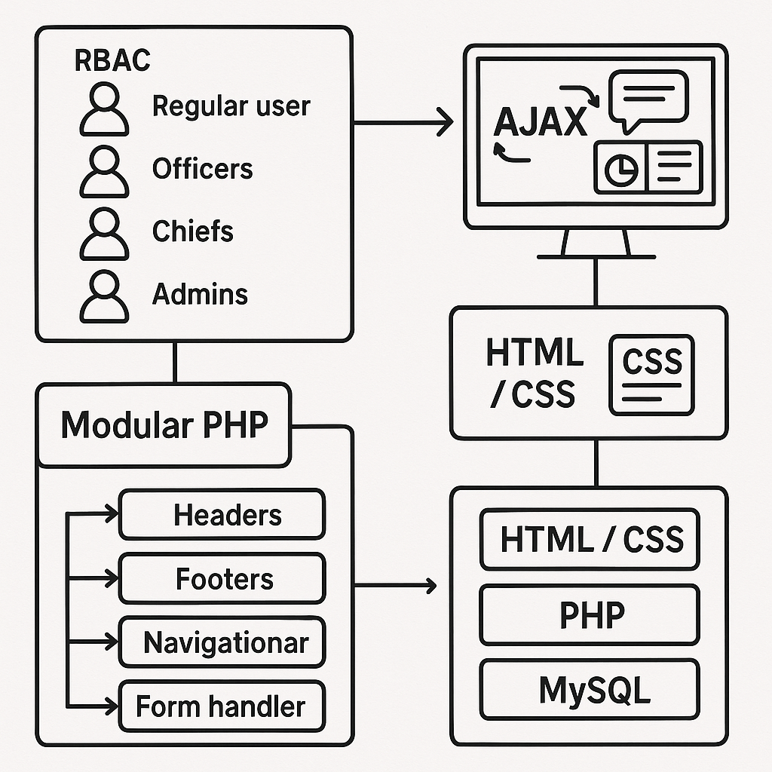
Fig 3.8 Crime Reporting and Monitoring System Architecture

3.3.13 System Architecture
The system architecture is designed using best practices in web application development to promote scalability, security, and maintainability. The architecture integrates multiple technologies and organizational principles as described below:
- Role-Based Access Control (RBAC) is implemented to ensure that each user can only access features and data relevant to their assigned role. Regular users can report crimes and view updates, officers can give feedback and investigate, chiefs have extended monitoring access, while admins manage users and system-wide operations.
- AJAX (Asynchronous JavaScript and XML) is used in parts of the system, especially within dashboards and feedback areas, to allow seamless updates without reloading the entire page. This enhances responsiveness and improves the user experience.
- The application uses modular PHP include and require statements to separate reusable components such as headers, footers, navigation bars, and form handlers. This reduces code repetition and makes the system easier to maintain and update over time.
- The architecture follows the Model-View-Controller (MVC) principle to some extent. HTML and CSS handle the presentation layer (View), PHP scripts serve as the logic layer (Controller), and the MySQL database acts as the data layer (Model). While the structure is not implemented as a full MVC framework, this separation of concerns improves clarity and debugging efficiency.

CHAPTER FOUR
SYSTEM IMPLEMENTATION, TESTING AND RESULTS
4.1 System Implementation
System implementation refers to the actual development and installation of the Crime Reporting and Monitoring System. After completing the system design, the implementation stage involved coding, interface design, and integration of the various modules, followed by initial deployment and testing. The implementation phase transformed the theoretical design and architecture into a functioning application through programming, database development, front-end interface construction, and server configuration. This stage also included internal testing and validation to ensure the system performed as expected in various scenarios.
4.1.1 Hardware Requirement
The system was implemented using a standard computer setup commonly available in offices or web development laboratories. The hardware requirements provided a stable environment to run both the development tools and the web server for testing and deployment. The following are the essential hardware components that were used for development and implementation:
- A personal computer powered by at least an Intel Core i3 processor, offering sufficient processing power for multitasking and running web server applications.
- A minimum of 4 gigabytes (GB) of RAM to handle simultaneous processes such as code compilation, local server hosting, and browser-based interface testing.
- A 500-gigabyte (GB) Hard Disk Drive or a Solid-State Drive (SSD) for storing project files, databases, logs, backups, and evidence-related media such as images and videos.
- Standard input devices including a functional keyboard and optical mouse, which facilitated data entry and system navigation during both development and testing.
- A monitor with a minimum screen resolution of 1366x768 pixels, offering sufficient screen space for frontend interface design and database configuration tasks.
- An internet-enabled network interface card (NIC) that provided connectivity for remote testing, system updates, file uploads, and optional future deployment on a cloud platform.
4.1.2 Software Requirement
The successful development and deployment of the Crime Reporting and Monitoring System required a suite of software tools that worked together to form the application environment. These tools covered both server-side and client-side development, along with database administration and debugging support. The essential software components used during implementation are as follows:
- Operating System: Windows 10 (64-bit) was chosen as the development operating system due to its wide compatibility with web development tools, support for various drivers, and familiarity among developers.
- Web Server: The Apache HTTP server bundled in the XAMPP software package was used to host the application locally during development. It offered reliability, ease of configuration, and full PHP support.
- Programming Language: The server-side functionality of the system was built using PHP, version 8.0 or higher. PHP provided dynamic processing capabilities and seamless integration with the MySQL database engine.
- Frontend Languages: The user interface was crafted using a combination of Hypertext Markup Language (HTML), Cascading Style Sheets (CSS), and JavaScript. These technologies handled content structure, visual styling, and client-side interactions, respectively.
- Database Server: MySQL was selected as the relational database management system (RDBMS). It allowed structured data storage and retrieval through SQL queries and was administered via the phpMyAdmin interface.
- Development IDE: Visual Studio Code (VS Code) served as the Integrated Development Environment. It offered real-time syntax checking, intelligent code completion, and plugin support for PHP, HTML, and JavaScript.
- Web Browsers: Google Chrome and Mozilla Firefox were used extensively for frontend testing and rendering. These browsers provided advanced developer tools for debugging and performance analysis.

4.1.3 Program Development
The development of the Crime Reporting and Monitoring System was carried out using a modular programming strategy. This approach allowed the system to be divided into several interconnected but independently manageable components. Each module addressed a specific functionality such as user registration, crime reporting, feedback from law enforcement, administrative monitoring, and data analytics.
The development process began by mapping out the individual modules on paper, identifying their input, output, and interrelationships. These designs were later translated into actual code and tested in isolation before being gradually integrated into the complete system. The modular design not only made debugging easier but also improved future maintenance and scalability. This approach also facilitated better teamwork, as different modules could be assigned to different developers simultaneously without interfering with one another’s work.
The development followed a pattern that ensured separation of concerns. For instance, database access logic was separated from user interface rendering, and form validations were handled independently. With the use of reusable PHP includes, the project structure remained neat and easy to navigate throughout the implementation phase.

4.1.3.1 Choice of Programming Language
The programming languages chosen for developing the system were primarily PHP, HTML, CSS, and JavaScript. PHP served as the core language for handling server-side logic, managing database communication, and executing system processes such as login authentication, data validation, and report submission.
HTML was used for creating the structural layout of the web pages, ensuring the interface elements were well-positioned and semantically organized. CSS was employed for the styling and design aspect, making the user interface clean, visually appealing, and responsive across various devices. JavaScript, on the other hand, was used to enhance interactivity within the system, such as toggling views.
The selection of these languages ensured cross-browser compatibility, ease of deployment, and widespread community support, all of which are critical for a public-facing system like crime reporting.

4.1.3.2 Language Justification
The choice of PHP as the backend language was driven by several important factors. Firstly, PHP has native support for MySQL, the database system used in this project. This integration simplifies querying, data retrieval, and manipulation operations, which are fundamental in a crime reporting application.
Secondly, PHP is open-source and widely supported, making it cost-effective and rich in libraries, documentation, and developer communities. It supports both procedural and object-oriented programming paradigms, offering flexibility depending on the complexity of the module being implemented. This made PHP a suitable tool for handling modules like login systems, session management, and role-based access control.
For the frontend, HTML and CSS were chosen because of their standard role in webpage structuring and design. CSS allowed the design to reflect a professional and government-standard layout. JavaScript was essential for creating a dynamic and responsive user experience. It allowed users to receive instant feedback on form submissions, perform client-side validation, and interact with menus and dashboards smoothly.
Overall, the selected languages provided a balanced blend of stability, performance, scalability, and maintainability required for building a secure and user-friendly crime monitoring web application.
4.1.4 Main Menu Implementation
Fig 4.1 Navigation interface
The main menu of the Crime Reporting and Monitoring System serves as the primary navigational interface for users and is positioned prominently at the top of Home page. It provides quick access to the major functional areas of the platform, including the homepage, anonymous crime reporting section, crime analysis and result section, law enforcement sections, frequently asked questions (FAQs), user registration, and login features.
To implement this menu, semantic HTML5 elements were used to create a structured and accessible layout. The <nav> tag was utilized to encapsulate the menu structure, ensuring compliance with modern web standards and improving readability for assistive technologies. Each menu item was coded as a hyperlink using the <a> tag nested within an unordered list (<ul>), which is a best practice for constructing clean and maintainable navigation bars.
CSS3 was employed to style the main menu, providing a responsive and visually consistent experience across various screen sizes and devices. The layout was made flexible using CSS Flexbox, which ensured that menu items adjusted and aligned properly even on smaller devices such as mobile phones. Additionally, a hover effect was introduced to enhance user interactivity and guide user attention.
JavaScript was used to add interactive functionality to the menu, particularly for mobile responsiveness. A collapsible menu system was implemented to accommodate smaller screen widths, whereby a "Menu" button toggles the visibility of navigation links using JavaScript event listeners. This ensures a user-friendly experience across desktops, tablets, and smartphones, thus aligning with modern usability principles.
The implementation of the main menu followed a modular and reusable design pattern, allowing consistent inclusion across all pages through a PHP include statement, which enhances code manageability and system consistency.
4.1.5 Sub Menu Implementation
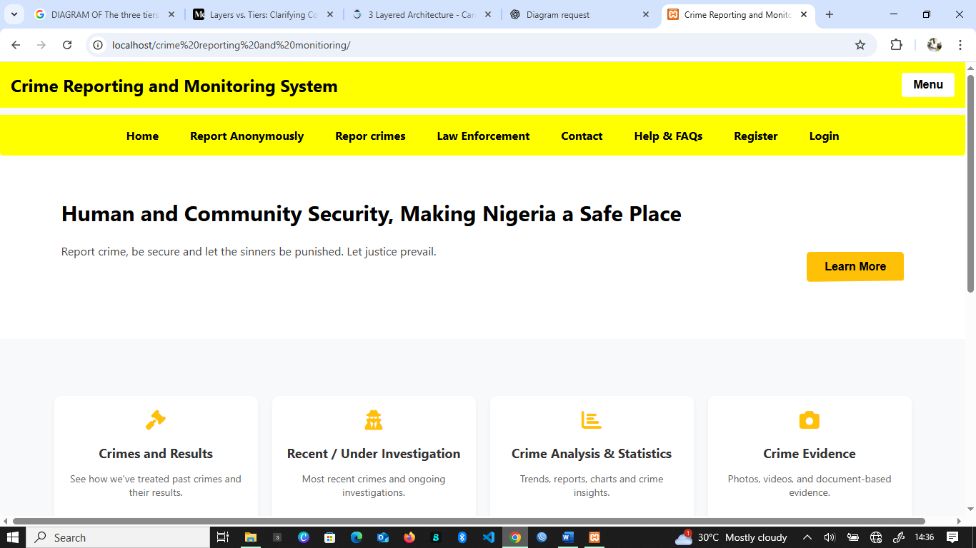
Fig 4.2 Sub menu interface
In addition to the primary menu links, the system features dynamic submenus that provide access to more specific modules within broader categories. For instance, under the "Crime Result & Analysis" section, submenus include links to “Past Crimes,” “Unsettled Crimes,” “Under Investigation,” and “Crime Charts.” Similarly, the "Law Enforcement" section contains sub-links to modules such as “Officer Listings,” “Community Chiefs,” and “Security Feedback.”
The submenus were implemented using a combination of HTML, CSS, and JavaScript. Each submenu was structured as a nested unordered list within its parent menu item, keeping the markup semantic and accessible. The visibility of these nested lists is controlled using CSS class toggling, which allows for an intuitive hover or click-triggered expansion depending on the user’s interaction pattern.
CSS was used to manage the default hidden state of submenus and their visibility upon interaction. Smooth transition effects were added to enhance the user experience when the submenu opens or closes. This visual feedback helps users understand the system structure and navigate with ease.
JavaScript played a crucial role in controlling the submenu behavior, particularly for devices that do not support hover actions such as touchscreen smartphones.
This submenu system not only enhances the navigational depth of the application but also maintains a clean and uncluttered interface by displaying detailed options only when necessary. By combining structural HTML, modern CSS, and JavaScript, the submenu was successfully designed to be both functional and aesthetically pleasing, aligning with the overall goal of providing a user-friendly crime reporting platform.
4.1.6 Program Module Implementation
The implementation of the Crime Reporting and Monitoring System was carried out using a modular programming structure, where each functional component of the application was developed as an independent yet interconnected module. This approach ensured a clean separation of concerns, enhanced maintainability, and allowed for easier testing, debugging, and scalability of the application. The primary modules implemented in the system include the Crime Reporting Module, Feedback Module, and Dashboard Modules for the various user roles within the system. Each module is described in detail below.
- Crime Reporting Module
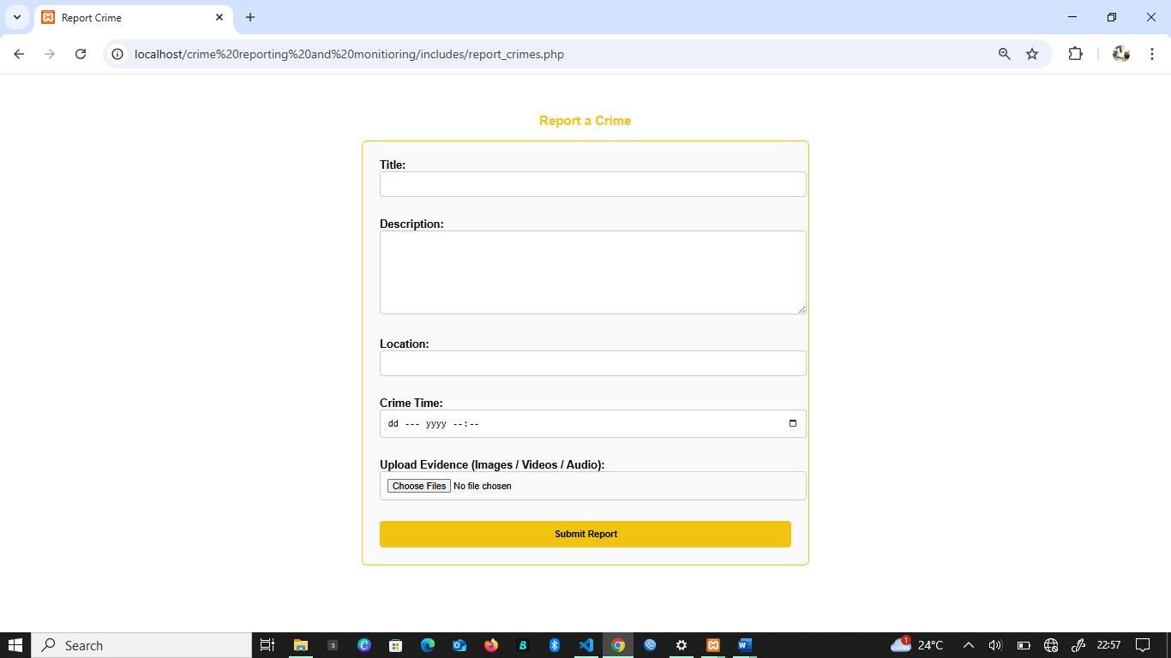
Fig 4.3 Crime reporting form Template
This module serves as the core functionality for users who wish to report criminal incidents. It was implemented as a form-driven interface using HTML and PHP. When a user submits a report, the module validates all input fields such as crime title, location, date and time of the incident, and a detailed description. An option is provided to choose whether the report should be submitted anonymously or with personal identification. The module also supports file uploads, allowing users to attach relevant evidence such as photographs, video clips, or document scans. These uploaded files are stored in a designated folder on the server, and the file path is saved in the database alongside the crime record. Upon successful submission, the crime data is stored in the crimes table in the MySQL database using secure, parameterized queries via PHP Data Objects (PDO) to prevent SQL injection attacks.
- Feedback Module
This module is accessible only to authenticated and approved users in the role of security officers and community chiefs. Its primary purpose is to allow them to provide updates or remarks on
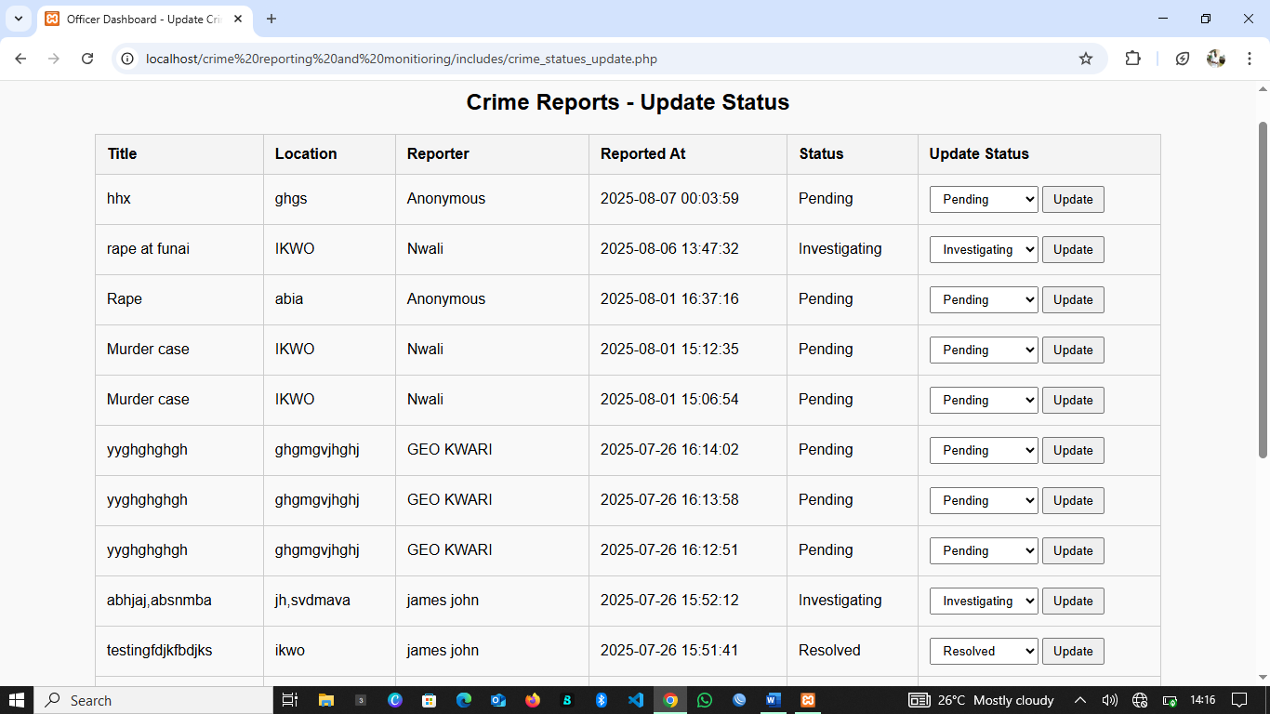
Fig 4.4 Crime status update
reported crimes. Each crime report is assigned a unique identifier, and feedback entries are linked to these reports through a foreign key relationship. Officers can use this module to update the status of a case such as marking it as “under investigation” or “resolved” and attach additional remarks or supporting documents if needed. A timestamp is automatically recorded whenever feedback is added. The feedback is stored in the feedback table, which includes references to both the officer and the related crime record. This module enhances transparency and allows other users (especially the original reporter) to track progress on their submissions.
- Dashboard Modules
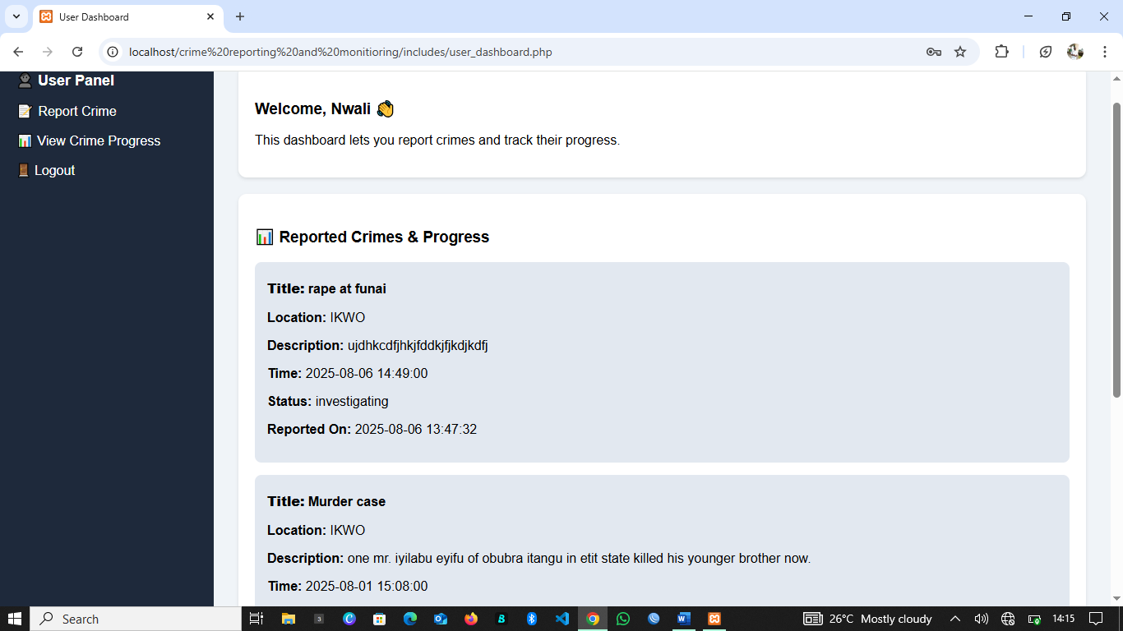
Fig 4. 5 user Dashboard
The system features separate, role-specific dashboards for three categories of users: Administrators, Security Personnel, and Community Chiefs. Each dashboard is dynamically generated based on the logged-in user’s role and privileges. For administrators, the dashboard provides a global overview, including total crime reports, pending feedback, officer activity logs, and statistical charts generated through Chart.js. Security personnel and chiefs are shown crime cases within their jurisdiction or assigned region. The dashboard content is loaded dynamically using AJAX (Asynchronous JavaScript and XML), which enables real time updates and a seamless user experience without the need for page reloads. This modular dashboard design improves usability by displaying only relevant information and tools for each user type while maintaining system integrity and security.
By structuring the application around these independent but cooperative modules, the development process remained organized and logical. This modular design approach also provides a strong foundation for future updates, such as adding new roles, integrating third-party APIs, or scaling the system for larger communities or nationwide deployment.
4.3 System Testing
System testing is a critical phase in the development of the Crime Reporting and Monitoring System. It ensures that all modules and integrated components function correctly, securely, and as expected. The testing phase includes Reporting functionalities, user interfaces, access control, and overall system performance under real-world usage conditions.
The primary goal of testing this system is to identify and resolve any defects before deployment, to ensure that users (citizens, officers, admins, and chiefs) can report, track, and respond to crimes efficiently.
4.3.1 Test Plan
The test plan outlines the strategy, scope, schedule, and responsibilities for testing the system. Testing is categorized into unit testing, integration testing, system testing, and user acceptance testing (UAT).
a. Objectives of Testing
- To verify that all functionalities meet the system requirements
- To validate data processing logic and access control
- To ensure the system handles errors and invalid inputs gracefully
- To confirm system usability and user role restrictions (e.g., community chief cannot access admin privileges)
b. Test Environment
- Backend: PHP (Core), MySQL
- Frontend: HTML, CSS, JavaScript
- Server: Localhost (XAMPP) and live hosting environment
- Browsers: Chrome, Firefox, Opera (for compatibility testing)
- Devices: Desktop, Android phones view with Desktop
c. Test Types Used
Table 4.1 Test types used and description.
Test Type | Description
Unit Testing | Testing individual modules like report submission, login, and dashboard logic
Integration Testing | Testing combined modules such as crime submission, approval and feedback flow
Functional Testing | Checking user roles, login validation, and crime tracking functionalities
Security Testing | Ensuring only authorized users can access sensitive data and admin panel
Usability Testing | Verifying that users can navigate and interact with the platform easily
Performance Testing | Checking system response with multiple users or large volumes of reports

4.3.2 Test Data
To properly simulate real-world use and assess the system’s functionality, a set of structured dummy data was created and inserted into the MySQL database. This test data represented various user roles and operational scenarios, allowing for a broad and accurate simulation of real system interactions.
- Crime Reports
Fictitious crime cases were created with different titles, locations, descriptions, and timestamps. Some reports were marked as anonymous, while others included user identifiers. These reports tested the system's ability to accept input, upload files, and store records in the database.
- User Registrations
Test user accounts were created representing different roles such as general users, officers, community chiefs, and administrators. Each account was assigned unique credentials and simulated approval processes to validate the registration, login, and access control mechanisms.
- Feedback Entries
Test feedback records were created and linked to existing dummy crime cases. These entries included status updates (e.g., "investigating", "resolved") and remarks from fictional officers. They were used to test the relational integrity of the database, as well as the display logic on officer dashboards.
- System Logs and Session Handling
Various user sessions were initiated to test login persistence, access restriction for unauthorized roles, and redirection upon invalid operations (e.g., accessing the admin dashboard as a regular user). Logs were used to monitor user activity and detect potential bugs.
- Upload Testing
Files such as JPEG images and PDF documents were uploaded via the reporting form to test server-side file handling and database path referencing. Limits on file size and file types were tested to ensure proper validation.
The use of this diverse and representative dataset enabled realistic testing and validation of the system’s reliability, performance, and security. Through iterative rounds of testing with this data, necessary refinements were made to ensure the system was stable and ready for deployment in a real-world environment.
4.4 Test Results
Throughout the testing process, the system's key modules were evaluated under simulated real-world conditions using dummy data, multiple user roles, and diverse device types. Each test case was compared against the expected outcome to verify system correctness, stability, and user experience. The testing confirmed that the system is stable, secure, and behaves in accordance with the project’s functional requirements.
- Crime Reporting Module
  - The system successfully received and stored user-submitted crime reports.
  - Optional uploads (e.g., images, PDFs) were validated and saved.
  - Reports instantly reflected on admin and officer dashboards.
  - Confirmation messages were correctly displayed after submission.
- Feedback Module
  - Officers were able to add updates (e.g., "under investigation", "resolved").
  - Attachments and comments were saved and linked using crime_id.
  - Feedback displayed correctly to all roles (admin, users, officers).
- Registration and Login System
  - Unauthorized users were denied access to protected pages.
  - Admin approval activated role-specific dashboards.
  - Password hashing, input validation, and session handling worked securely.
- Role-Based Dashboards
  - Admin dashboard displayed analytics and user management.
  - Officers saw local crime reports and could add responses.
  - Chiefs viewed trends in their communities.
  - Users could track their submitted reports.
- Navigation and Responsiveness
  - Menus and submenus loaded correctly on desktop and mobile.
  - All links, buttons, and dropdowns behaved as expected.
4.4.1 Actual Test Result versus Expected Test Result
Table 4.2 summary of Results and Expected Results
Test Case | Expected Result | Actual Result | Status
Submit a crime report (with optional file) | Data saved in DB, file uploaded, user notified, dashboards updated | All actions completed successfully | Passed
Officer gives feedback on a crime case | Feedback saved, linked to report, visible to users and admin | Exactly as expected, with correct linkage | Passed
Register a new user | User added to DB, no dashboard access until approved | Worked correctly; user access restricted until approved for security pesonnel and community chief | Passed
Attempt login with wrong password | Show error message without system crash | Error displayed properly, login prevented | Passed
Admin approves user and assigns role | User gains dashboard access based on assigned role | Exactly matched expected behavior | Passed
View dashboards as Admin, Officer, Chief, and User | Each role sees only relevant features and data | Role-based dashboards loaded accurately | Passed
Click dropdown menus on mobile | Menus expand/collapse correctly | Smooth animations and responsive menus confirmed | Passed
Session timeout or logout | User redirected to home page; session variables cleared | Behaved correctly without leaving active session open | Passed

4.4.2 Performance Evaluation
A performance evaluation was conducted to determine how efficiently the system operated in practical usage conditions. The evaluation focused on key performance indicators such as system response time, user interface behavior, load handling, and browser compatibility.
- The System Response Time was measured for major user interactions, including form submissions, page loads, and dashboard transitions. In nearly all cases, these actions were completed within 1.5 to 2 seconds, indicating a fast and responsive interface suitable for real-time usage.
- The system was tested using sample datasets simulating small to medium user populations and crime records, and no significant degradation in performance was observed. Even with increased dummy records and multiple simultaneous sessions, the pages maintained smooth transitions and stable interaction flow.
- Form Validations and File Uploads were processed promptly, and file sizes up to the predefined limits (2MB for images and 5MB for documents) were successfully handled by the server. Uploaded evidence files were saved into appropriate directories, and their paths were correctly referenced within the database and frontend views.
- The application was also evaluated for cross-browser compatibility. All core features were successfully tested on modern browsers, including Google Chrome, Mozilla Firefox, and Microsoft Edge. The layout, styling, and JavaScript-based interactions remained consistent across platforms, confirming that the system was not browser-dependent and could cater to a wide user base.
- Security Performance was also observed. Session tokens were verified correctly, user sessions were automatically logged out after inactivity, and there were no incidences of unauthorized access when direct URL access was attempted.

4.4.3 Limitation of the Result
Despite the successful implementation and testing of the Crime Reporting and Monitoring System, several limitations were encountered during the evaluation phase, primarily due to environmental and resource constraints.
The system was tested using a local development server (XAMPP) within a single-machine setup. This restricted the ability to assess performance under high-load conditions, such as simultaneous access by multiple users or large-volume data uploads. Real-world applications of such a system would typically require deployment on a live server or cloud environment capable of handling increased traffic, secure sessions, and concurrent user operations. However, due to infrastructure limitations, such stress testing could not be conducted in this phase.
Another notable limitation was the incomplete integration of SMS and email notification features, which were originally intended to alert users and security personnel when new reports or feedback entries were submitted. The placeholder logic for these functions exists within the codebase, but actual delivery via messaging APIs (e.g., SMTP for email or SMS gateways for text messaging) was not implemented. As a result, real-time communication between the system and its users remains partially functional, relying only on browser-based alerts and dashboard updates.
Additionally, the system’s mobile responsiveness was tested on desktop emulators rather than real mobile devices due to hardware access limitations. This restricted comprehensive validation of user experience across varying screen sizes and operating systems.
Lastly, while the system supports image, video, and document evidence uploads, larger media files were not fully stress-tested due to bandwidth and file size limitations on the local server. Thus, scalability in handling high-definition video evidence or massive case files remains to be evaluated in future iterations.
These limitations, although not critical to the core functionality, represent areas for enhancement in future upgrades and live deployment scenarios.

4.4.4 Results and Discussions
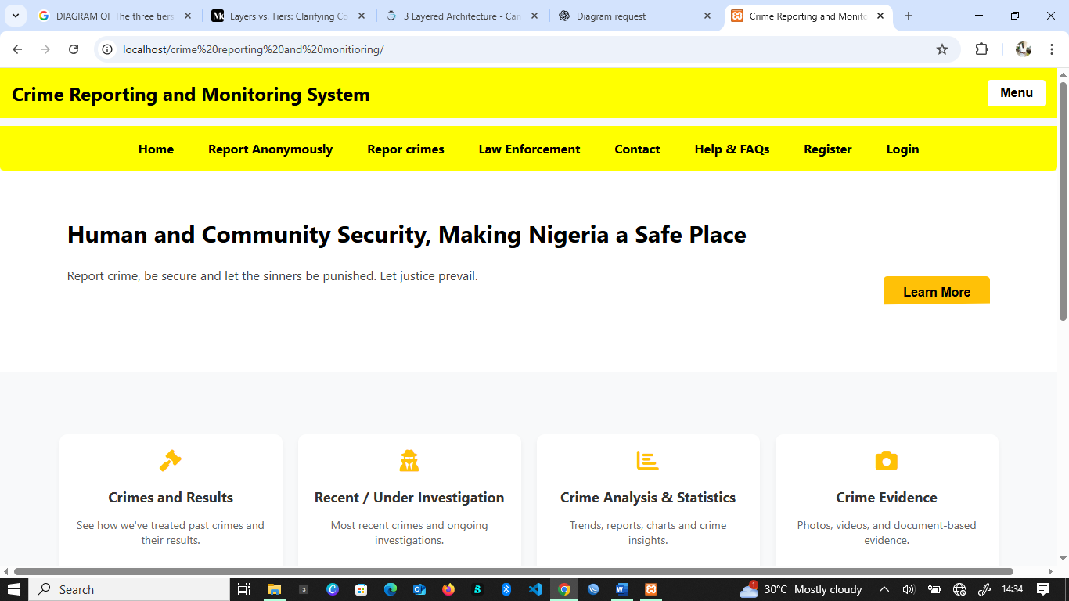
Fig 4.6 Home page of crime Reporting and monitoring system.
The overall results obtained from the testing phase confirm that the developed Crime Reporting and Monitoring System successfully achieved its stated objectives. The platform allowed users to submit crime reports efficiently and anonymously, provided separate role-based dashboards for officers, chiefs, administrators, and general users, and enabled security personnel to respond to submitted cases with timely feedback.
The anonymity feature worked flawlessly, allowing users to submit reports without revealing their identities while still tracking the status of their submissions. File upload functionality covering images, documents, and videos was operational and correctly linked each file to the appropriate crime record.
During the discussion sessions held with a small group of test users including students, security volunteers, and administrative staff, feedback was gathered on the system’s usability. Most users appreciated the clarity of the interface, the speed of operations, and the straightforward nature of the forms and menu navigation. However, several suggestions were made for future enhancement.
One recurring request was the development of a dedicated mobile app to allow users in remote or low-computer-access communities to participate more actively in crime reporting. Participants noted that many individuals are more comfortable using smartphones than computers, especially in rural and semi-urban areas.
Another suggestion was the incorporation of multi-language support, especially for regions where English is not the primary spoken language. Including local language translations would improve inclusiveness and encourage more widespread use of the platform across diverse communities.
Furthermore, test users proposed additional features such as a map-based crime location system, where crimes could be geotagged for spatial analysis and law enforcement planning.
In conclusion, the testing results affirm that the system functions as expected, providing a strong foundation for web-based crime reporting and response. Feedback obtained from real users presents a roadmap for future enhancements aimed at scaling the system for broader national or regional adoption.
4.5 System Security
Ensuring the security of both user data and system integrity was a key priority throughout the development of the Crime Reporting and Monitoring System. Given the sensitivity of the information involved particularly personal reports, evidence files, and law enforcement feedback the implementation incorporated multiple layers of security features to mitigate unauthorized access, data breaches, and malicious attacks.
At the foundational level, user authentication was enforced using PHP session management, allowing only logged-in users to access protected resources. Sessions were uniquely initialized upon successful login and destroyed upon logout, minimizing the risk of session hijacking. Role-based access control was also implemented, ensuring that each user type (e.g., admin, officer, chief, citizen) could only access specific parts of the system assigned to their privileges.
To protect user credentials, passwords were never stored in plain text. Instead, during user registration and login, passwords were encrypted using a secure one-way hashing algorithm specifically password_hash() and password_verify() functions in PHP. This method protects user passwords even in the event of database compromise.
In addition, the system was fortified against common web vulnerabilities through input validation and sanitization techniques. All form inputs were validated using both client-side JavaScript and server-side PHP logic. PHP’s built-in filter_var() and mysqli_real_escape_string() functions were used to sanitize inputs and prevent SQL injection attacks, which could otherwise allow malicious users to manipulate the database. To defend against Cross-Site Scripting (XSS), all user-generated content displayed on the interface was escaped using the htmlspecialchars () function, ensuring that scripts could not be executed in the browser.
File uploads, particularly crime evidence (images, documents, and videos), were handled carefully. Files were restricted by type and size, renamed upon upload to prevent direct path exposure, and stored in designated directories inaccessible by direct URL without verification.
Collectively, these strategies created a secure application environment capable of safeguarding users and protecting the integrity of the data processed by the system.
4.6 System Integration

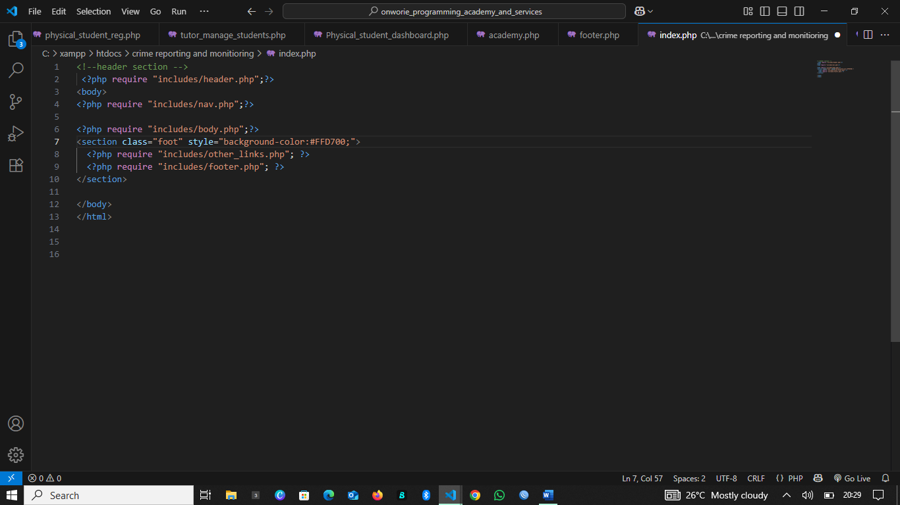
Fig 4.7 interface of systerm integration with php includes
System integration involved the process of combining various independently developed modules and components into a single, cohesive application. The architecture of the Crime Reporting and Monitoring System followed a modular design strategy, which allowed for seamless assembly of different subsystems without disrupting overall performance.
A key integration technique used during development was the application of PHP includes, a method that allows the reuse of code fragments across multiple pages. Common layout components such as headers, navigation menus, sidebars, and footers were separated into their own files (e.g., header.php, footer.php) and included in relevant pages. This not only ensured visual and functional consistency across the site but also simplified future updates and maintenance.
All modules such as user registration, crime reporting, feedback submission, dashboard statistics, and data analysis were linked through a well-defined workflow that passed data between pages using HTTP methods and PHP session variables. The navigation menu served as the central control point, granting users access to the different modules based on their login status and assigned roles.
Integration at the database level was equally critical. Using relational database design, MySQL tables were interlinked through foreign keys. For example, the feedback table referenced the crimes table via a crime_id foreign key, and the crimes table was connected to the users table through user_id. These relationships ensured data consistency and enabled complex joins that powered dashboard views and user-specific reports.
Data flows were carefully tested to ensure each component correctly interacted with the others. Form data from the frontend was passed to backend scripts, which processed, validated, and stored information in the database. Data from the database was then retrieved and dynamically rendered on user dashboards, report listings, and analysis pages.
In summary, system integration ensured that every part of the application communicated effectively, enabling a seamless and intuitive experience for all user roles.
4.7 Documentation
Documentation formed an integral part of the system development process, serving two distinct but equally important audiences: end-users and future developers. Proper documentation enhances the usability, maintainability, and scalability of the application by providing clear guidance on system usage and internal structure.
For end-users, user documentation was created in the form of a simple, well-structured user guide. This guide included step-by-step instructions on how to perform core tasks such as registering on the platform, logging in, submitting crime reports, uploading evidence, checking investigation feedback, and interpreting dashboard charts. Each section was supplemented with screenshots and explanations to ensure accessibility even for non-technical users. The aim was to lower the barrier for citizen participation, especially in communities with limited digital literacy.
On the other hand, developer documentation was prepared to assist technical personnel who may maintain or upgrade the system in the future. This included a detailed breakdown of the file structure, describing the purpose and functionality of each script and template. The database schema was thoroughly documented using an entity-relationship diagram and table-by-table explanation, outlining each field, its data type, relationships, and constraints. Installation instructions were also included, specifying the software environment, directory permissions, and necessary configurations to replicate or deploy the system on another server.
In addition, inline comments were written throughout the PHP, HTML, and JavaScript codebases to explain logic, enhance readability, and support team collaboration in future development cycles.
Overall, the documentation ensured that users could interact confidently with the platform and that future developers would be well-informed in their effort to maintain, troubleshoot, or extend the system.

CHAPTER FIVE
SUMMARY, CONCLUSION AND RECOMMENDATIONS
5.1 Summary
This research project centered on the design and implementation of a web-based Crime Reporting and Monitoring System tailored to improve public safety outcomes, encourage active citizen participation, and strengthen the connection between the general public and law enforcement agencies. The primary motivation behind this project was the observed inefficiency and inaccessibility in the existing, mostly manual, crime reporting procedures. These traditional systems depend heavily on physical visits to police stations, handwritten reports, and verbal communication, which are not only time-consuming and bureaucratic but also discourage many citizens from reporting crimes especially in rural or underserved areas.
The newly developed system aimed to address these challenges by introducing a digital alternative that simplifies reporting processes, supports anonymity, allows media uploads, and makes tracking crime investigations possible in real time. This approach helps eliminate fear of retaliation, increases transparency, and makes law enforcement more responsive and accountable to the public.
To achieve this, the prototyping software development methodology was adopted. This methodology was well-suited to the project because it allowed for incremental development with frequent feedback from intended users including regular citizens, security personnel, and community chiefs. The feedback obtained during interviews and surveys contributed significantly to refining the system’s interface and features, ensuring that the end product aligned with real-world expectations and needs.
The implementation phase involved the use of modern web development technologies. PHP was chosen for server-side programming due to its robustness and compatibility with MySQL databases. HTML, CSS, and JavaScript were utilized to build the front-end interface, ensuring that users experienced smooth navigation, form handling, and visual feedback. MySQL served as the backend database, managing large volumes of user data, crime reports, feedback, and evidence uploads. The overall system was built on a modular architecture that ensured separation of concerns and easier maintenance.
Key system features included:
- Role-based dashboards for different user categories (admin, user, officer, and chief)
- Anonymous reporting options
- Secure evidence uploads (images, videos, documents)
- Feedback submission by authorized personnel
- Status tracking for reported crimes
- A centralized database for secure and efficient storage
In the course of development, multiple levels of system testing were carried out to ensure functional correctness, security, and performance. Unit testing was used to verify the accuracy of individual modules; integration testing ensured that these modules worked seamlessly together; and user acceptance testing was conducted to validate that the system met the expectations of its end users.
The results of these tests confirmed that the system was able to perform its core functions effectively. Users were able to report crimes, security personnel could respond and update investigation statuses, and administrators had access to analytics dashboards displaying overall activity. Although there were some limitations such as the lack of real-time email or SMS notification support and an inability to test under high-traffic or cloud-hosted conditions due to local hosting constraints these did not diminish the system’s operational value within its current scope.
In conclusion, the project succeeded in creating a reliable digital platform for reporting and monitoring crime in Nigerian communities. It laid the groundwork for future improvements and larger-scale deployment, with the potential to significantly reshape how crime is reported, tracked, and addressed nationwide.
5.2 Conclusion
The completion and deployment of the Crime Reporting and Monitoring System represents a meaningful advancement in the application of digital technologies to enhance public safety, promote civic responsibility, and reinforce cooperation between citizens and law enforcement agencies in Nigeria. In a society where crime often goes unreported due to fear, distrust, or lack of access, this system provides a viable alternative that is inclusive, secure, and easy to use.
The project successfully addressed core issues present in the traditional crime reporting mechanisms—chiefly, the inefficiency of manual procedures, lack of anonymity, limited accessibility, and poor feedback channels. By providing a platform that accommodates anonymous crime submissions, multimedia evidence uploads, and real-time monitoring of investigations, the system promotes transparency and empowers everyday citizens to become active participants in the fight against crime without exposing themselves to undue risks or intimidation.
From a technical perspective, the system’s implementation using widely supported web technologies such as PHP, HTML, CSS, JavaScript, and MySQL proves that effective crime monitoring tools do not necessarily require complex or expensive software stacks. Instead, with thoughtful planning, a user-centered approach, and proper integration of basic tools, highly functional platforms can be developed to meet pressing societal needs.
Furthermore, the project demonstrates that community-based digital solutions can significantly improve the quality of engagement between citizens and security institutions. Law enforcement officers and community chiefs now have structured access to reports, feedback mechanisms, and evidence, enabling quicker responses, better prioritization of cases, and improved public trust.
The successful system testing and deployment show the system’s feasibility in real-world conditions. While limitations were encountered such as the absence of advanced notification systems and scalability challenges under high load these do not detract from the platform’s overall value. Rather, they highlight future development opportunities for integrating features like SMS/email alerts, mobile device compatibility, and multilingual support to serve a broader demographic.
In conclusion, this project has not only achieved its intended objectives but has also laid a strong foundation for digitally transforming crime management systems in Nigeria and beyond. It underscores the role that accessible technology can play in enhancing security, promoting justice, and fostering collaboration between the government and the governed. Going forward, continued investment in digital infrastructure, user education, and policy support will be critical in maximizing the system’s long-term impact and sustainability.
such a platform is both feasible and highly impactful, especially in environments where trust in traditional law enforcement structures is low. The project has laid the foundation for further digital transformation in public safety systems, highlighting the importance of community-based engagement, real-time communication, and data-driven decision-making in the justice sector.
While the system performs well within its current scope, there is room for expansion, including mobile application integration, support for indigenous languages, advanced analytics, and real-time alerting mechanisms. Nevertheless, the work accomplished in this project shows how technology can bridge the gap between citizens and security agencies, ultimately contributing to safer and more responsive communities.
5.3 Recommendations
Drawing upon the practical insights gained during the design, development, and testing phases of this project, as well as the feedback received from test users and stakeholders, several forward-looking recommendations are presented to enhance the effectiveness, adoption, and sustainability of the Crime Reporting and Monitoring System. These suggestions aim to address current limitations while positioning the system for long-term relevance and scalability in the fight against crime in Nigeria.
- The system should be deployed on a reliable cloud-based hosting infrastructure to ensure round-the-clock availability, improved performance, and ease of access from any location. Cloud deployment, when combined with domain registration and HTTPS encryption, will also improve system security, trust, and user confidence, especially when handling sensitive reports and evidence files.
- A dedicated system maintenance team comprising developers, data analysts, and administrative staff should be established to oversee the system’s technical health. This team will be responsible for routine backups, security patches, database optimization, and resolving technical issues as they arise, ensuring continuous uptime and minimal disruptions.
- There is a strong need for policy-level collaboration between the developers, government institutions, and national security agencies. By formally adopting the platform into the national policing infrastructure, data can be standardized, response protocols aligned, and the platform’s legitimacy recognized across various regions and jurisdictions. By implementing these recommendations, the Crime Reporting and Monitoring System can evolve into a national-level crime management solution that not only reduces crime rates but also fosters a stronger relationship between citizens and the institutions responsible for their safety.

References
Smith, J., & Brown, L. (2020). Global crime trends and their impact on economic development. Journal of International Security, 15(2), 120–138.
Jones, A. R. (2019). Underreporting in crime: Cultural, psychological, and systemic influences. Journal of Criminal Psychology, 4(1), 45–60.
Williams, S. (2021). Challenges in traditional crime reporting systems in remote areas. International Journal of Law Enforcement Studies, 9(3), 210–225.
Harris, E. (2019). The fear factor: How distrust hinders crime reporting. Criminal Justice Review, 32(4), 345–362.
Doe, J. (2018). Enhancing public safety through web-based crime reporting. Safety & Technology Journal, 2(1), 15–27.
Miller, T., & Davis, R. (2022). Real-time crime trend analysis using online platforms. Journal of Digital Law Enforcement, 7(1), 68–85.
Johnson, K. (2020). Integrating geolocation and encryption in modern crime reporting tools. International Security Technology Review, 28(4), 99–117.
Clark, P., & White, M. (2021). Transparency and feedback in criminal justice: Bridging public–police trust gaps. Law Enforcement Communications, 11(2), 50–67.
Roberts, N. (2021). Nigeria’s reliance on manual crime reporting: A systemic review. African Journal of Public Safety Studies, 5(1), 101–118.
Agrawal, A., & Agarwal, A. (2016). Online crime reporting system. International Journal of Computer Applications, 139(10), 21–24.
Akotam Agangiba, W. M., & Agangiba, M. (2023). Mobile method for tracking and documenting metro area crimes. Journal of Urban Safety and Crime Studies, 6(1), 22–34.
Arisukwu, O. C., Igbolekwu, C. O., Oye, A. J., Oyeyipo, E. J., Asamu, F., Rasak, B., & Oyekola, I. A. (2020). Community participation in crime prevention and control in rural Nigeria. Heliyon, 6(9), e05015. https://doi.org/10.1016/j.heliyon.2020.e05015
Ayodele, J. O., & Aderinto, A. A. (2014). Nature of crime and crime reporting of victims in Lagos, Nigeria. International Journal of Criminology and Sociological Theory, 7(1).
Bossler, A., & Holt, T. (2009). Online activities, guardianship, and malware infection: Routine Activities Theory. In Uduma et al. (2021).
Cohen, L., & Felson, M. (1979). Social change and crime rate trends: A routine activity approach. American Sociological Review, 44(1), 588–608.
Cornish, D. B., & Clarke, R. V. (2008). The reasoning criminal: Rational choice perspectives on offending. Transaction Publishers.
Elphick, C., Philpot, R., Zhang, M., Stuart, A., Walkington, Z., Frumkin, L., Pike, G., Levine, M., Price, B., & Nuseibeh, B. (2020). Building trust in digital policing: A scoping review of community policing apps. arXiv preprint, arXiv:2006.07140.
Garicano, L., & Heaton, P. (2010). Information technology, organization, and productivity in the public sector: Evidence from police departments. Journal of Labor Economics, 28(1), 167–206.
Gupta, M., & Gupta, P. (2024). Enhancing emergency response with cloud-integrated crime reporting systems. Journal of Smart Policing and Public Safety, 5(2), 73–85.
Gupta, P., & Gupta, S. (2024). Mobile cloud computing: The future of cloud. International Journal of Mobile and Cloud Computing, 5(2), 101–110.
Ismail, Z., & Zaki, M. (2016). Crime record management system: A case study. International Journal of Computer Science and Information Security, 14(6), 82–88.
Jacobsen, I. (1990). Object-oriented software engineering: A use case driven approach. Addison Wesley.
Jeffery, C. R. (2017). Crime prevention through environmental design. In Crime Opportunity Theories. Routledge.
Jimoh, A. A., Wajiga, G. M., & Garba, E. J. (2022). Software development for crime management in Nigeria. University of Ibadan Journal of Science and Logics in ICT Research, 8(1), 39–55.
Jimoh, R., Wajiga, G., & Garba, A. (2022). Development of a web-based crime reporting system using Python and MongoDB for Nigerian police. Nigerian Journal of Information Systems and Technology, 10(1), 45–58.
Jimoh, R. G., Ojulari, K. T., & Enikuomehin, O. A. (2022). A scalable online crime reporting system. Journal of Web-based Applications in Security, 4(1), 44–59.
Kavalleswari, A., & Dakshayini, M. (2024). Crime reporting management system using Android Studio. EasyChair Preprints (14657).
Kavalleswari, B., & Dakshayini, M. (2024). Development of an AngularJS and Cordova-based mobile crime reporting system. International Journal of Computer Engineering and Applications, 18(3), 34–42.
Oludele, A., Onuiri, E., Olaore, O., Sowunmi, O., & Ugo-Ezeaba, A. (2015). A real-time crime records management system for national security agencies. European Journal of Computer Science and Information Technology, 3(2), 1–12.
Shahnawaz, M. (2023). Crime reporting and crime updates. International Journal of Cyber Policing, 11(3), 55–67.
Uduma, N. E., Nwasum, C. J., Abaneme, E. C., & Ituma, E. I. (2021). We are watching them as they post: A mirror into the Nigerian Police Force use of social media and the challenges affecting its adoption in policing. Police Practice and Research, 22(5), 1524–1539.
Pressman, R. S., & Maxim, B. R. (2020). Software engineering: A practitioner’s approach (9th ed.). McGraw-Hill Education.

APPENDIX A: SOURCE CODE
<?php
error_reporting(E_ALL);
ini_set('display_errors', 1);
?>

<?php
require_once 'crime_db_con.php';

// Total crimes
$totalCrimes = $pdo->query("SELECT COUNT(*) FROM crimes")->fetchColumn();

// Crimes by status
$statusData = $pdo->query("SELECT status, COUNT(*) as total FROM crimes GROUP BY status")->fetchAll(PDO::FETCH_ASSOC);

// Crimes by locality
$localityData = $pdo->query("
SELECT u.locality, COUNT(*) as total
FROM crimes c
JOIN users u ON c.reported_by = u.id
GROUP BY u.locality
")->fetchAll(PDO::FETCH_ASSOC);

// Crimes per month
$monthlyData = $pdo->query("
SELECT DATE_FORMAT(crime_time, '%Y-%m') AS month, COUNT(*) as total
FROM crimes
GROUP BY month
ORDER BY month
")->fetchAll(PDO::FETCH_ASSOC);

// Anonymous vs named
$anonData = $pdo->query("
SELECT
SUM(CASE WHEN is_anonymous = 1 THEN 1 ELSE 0 END) as anonymous,
SUM(CASE WHEN is_anonymous = 0 THEN 1 ELSE 0 END) as named
FROM crimes
")->fetch(PDO::FETCH_ASSOC);

// ✅ Feedback count per officer (fixed table name: feedbacks)
$feedbackData = $pdo->query("
SELECT u.name, COUNT(*) as total
FROM feedbacks f
JOIN users u ON f.personnel_id = u.id
GROUP BY f.personnel_id
")->fetchAll(PDO::FETCH_ASSOC);
?>

<!DOCTYPE html>
<html>
<head>
<title>Crime Statistics Dashboard</title>
<script src="https://cdn.jsdelivr.net/npm/chart.js"></script>
<style>
canvas { max-width: 700px; margin: 30px auto; display: block; }
body { font-family: Arial, sans-serif; background: #f5f5f5; padding: 20px; text-align: center; }
</style>
</head>
<body>

<h1>Crime Reporting System - Statistics</h1>
<h3>Total Crimes: <?= $totalCrimes ?></h3>

<canvas id="statusChart"></canvas>
<canvas id="localityChart"></canvas>
<canvas id="monthlyChart"></canvas>
<canvas id="anonChart"></canvas>
<canvas id="feedbackChart"></canvas>

<script>
const statusData = <?= json_encode($statusData) ?>;
const localityData = <?= json_encode($localityData) ?>;
const monthlyData = <?= json_encode($monthlyData) ?>;
const anonData = <?= json_encode($anonData) ?>;
const feedbackData = <?= json_encode($feedbackData) ?>;

// Crimes by status
new Chart(document.getElementById('statusChart'), {
type: 'bar',
data: {
labels: statusData.map(d => d.status),
datasets: [{
label: 'Crimes by Status',
data: statusData.map(d => d.total),
backgroundColor: ['#f39c12', '#2ecc71', '#e74c3c']
}]
}
});

// Crimes by locality
new Chart(document.getElementById('localityChart'), {
type: 'pie',
data: {
labels: localityData.map(d => d.locality),
datasets: [{
label: 'Crimes by Locality',
data: localityData.map(d => d.total),
backgroundColor: ['#1abc9c', '#3498db', '#9b59b6', '#e67e22']
}]
}
});

// Crimes per month
new Chart(document.getElementById('monthlyChart'), {
type: 'line',
data: {
labels: monthlyData.map(d => d.month),
datasets: [{
label: 'Crimes Per Month',
data: monthlyData.map(d => d.total),
fill: false,
borderColor: '#2c3e50',
tension: 0.2
}]
}
});

// Anonymous vs named
new Chart(document.getElementById('anonChart'), {
type: 'doughnut',
data: {
labels: ['Anonymous', 'Named'],
datasets: [{
label: 'Anonymous vs Named Reports',
data: [anonData.anonymous, anonData.named],
backgroundColor: ['#8e44ad', '#2980b9']
}]
}
});

// Feedback per officer
new Chart(document.getElementById('feedbackChart'), {
type: 'bar',
data: {
labels: feedbackData.map(d => d.name),
datasets: [{
label: 'Feedback per Officer',
data: feedbackData.map(d => d.total),
backgroundColor: '#16a085'
}]
}
});
</script>

</body>
</html>

<!-- ADMIN DASHBOARD -->
<!DOCTYPE html>
<html lang="en">
<head>
<meta charset="UTF-8" />
<meta name="viewport" content="width=device-width, initial-scale=1.0" />
<title>Admin Dashboard</title>
<style>
body { display: flex; font-family: sans-serif; margin: 0; }
.sidebar { background: #111827; color: #fff; padding: 20px; width: 260px; height: 100vh; }
.sidebar h2 { font-size: 18px; }
.sidebar a { display: block; color: #fff; text-decoration: none; margin: 15px 0; }
.main { flex: 1; padding: 30px; background: #e2e8f0; }
.card { background: #fff; padding: 20px; border-radius: 10px; margin-bottom: 20px; box-shadow: 0 2px 4px rgba(0,0,0,0.1); }
</style>
</head>
<body>
<div class="sidebar">
<h2>🛠️ Admin Panel</h2>
<a href="user_management.php">👥 Manage Users</a>
<a href="crime_management.php">⚠️ Manage Crimes</a>
<a href="feedbacks.php">🗣️ provide feedback</a>
<a href="crime_statues_update.php">📬 Feedback</a>
<a href="analysis_and-statistics.php">📈 Crime Statistics</a>
<a href="logout.php">🚪 Logout</a>
</div>
<div class="main">
<div class="card">
<h3>Welcome, Admin 🧑‍💼</h3>
<p>Monitor all system users, crimes, and activity logs.</p>
</div>
<div class="card">
<h3>📊 Crime Stats</h3>
<p>Track daily, weekly and monthly crime data.</p>
</div>
<div class="card">
<h3>👥 User Management</h3>
<p>Approve, suspend, or delete any registered user.</p>
</div>
<div class="card">
<h3>⚠️ Crime Oversight</h3>
<p>Review and remove false or resolved crime reports.</p>
</div>
</div>
</body>
</html>

Appendix B – Sample Output

Fig6.1 crime report confirmation

Fig6.2 main menu

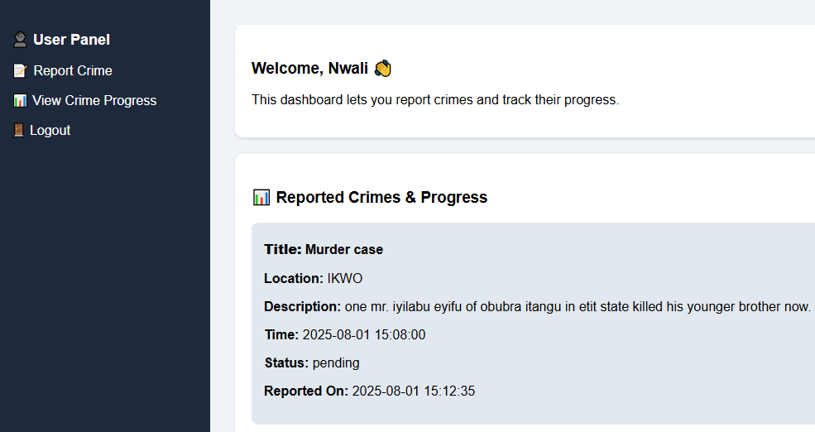
Fig 6.3 user dashboard with reported crime and progress

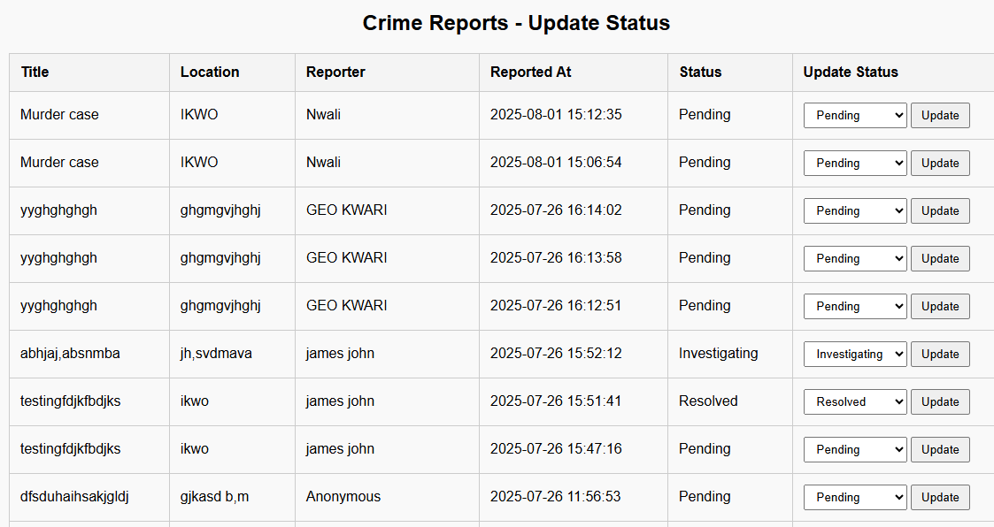
Fig 6.4 crime reports status update
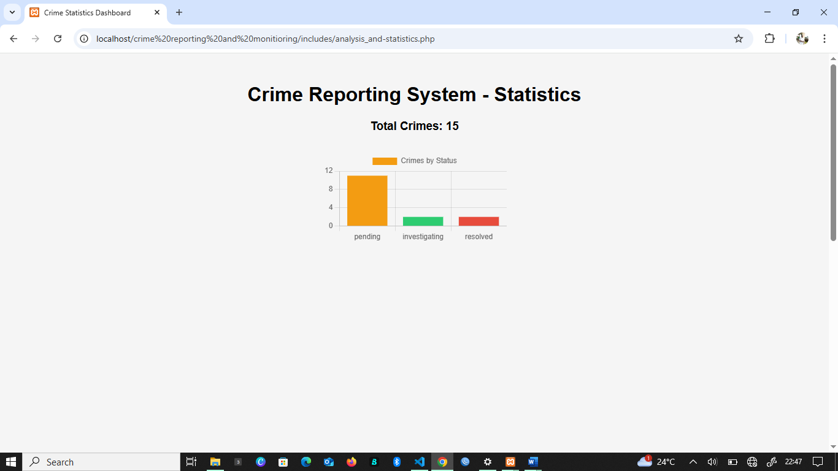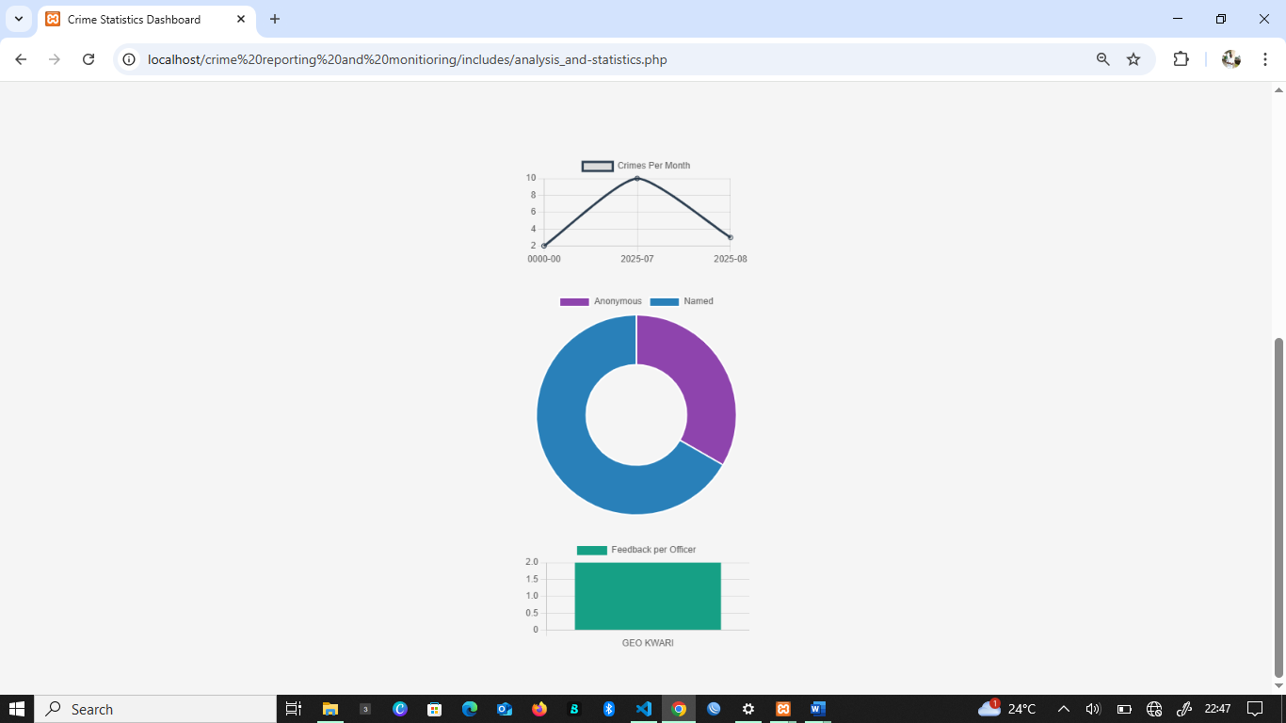
Fig 6.5 analysis and statistics of crimes


Fig 6.6 crime system home page

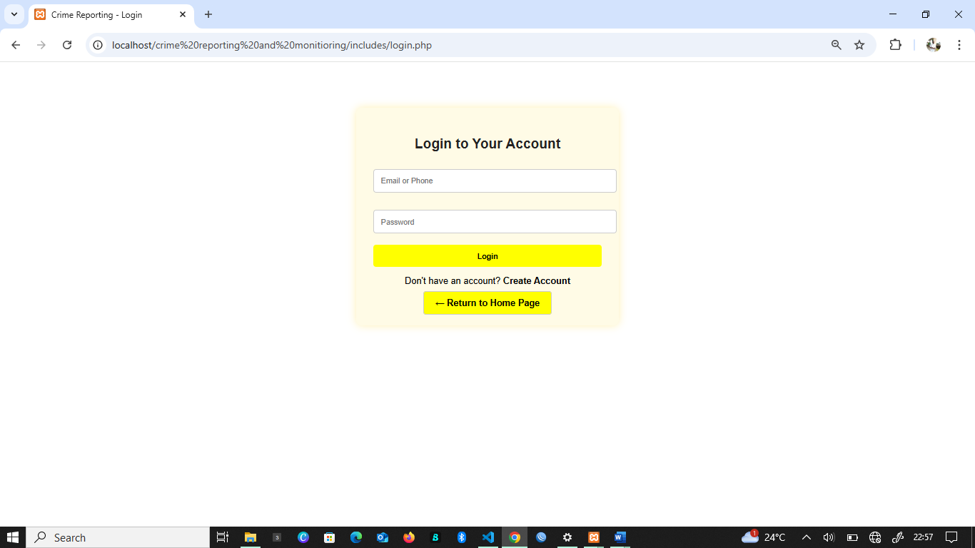
Fig 6.7 Login Page


Fig 6.8 crime Report form

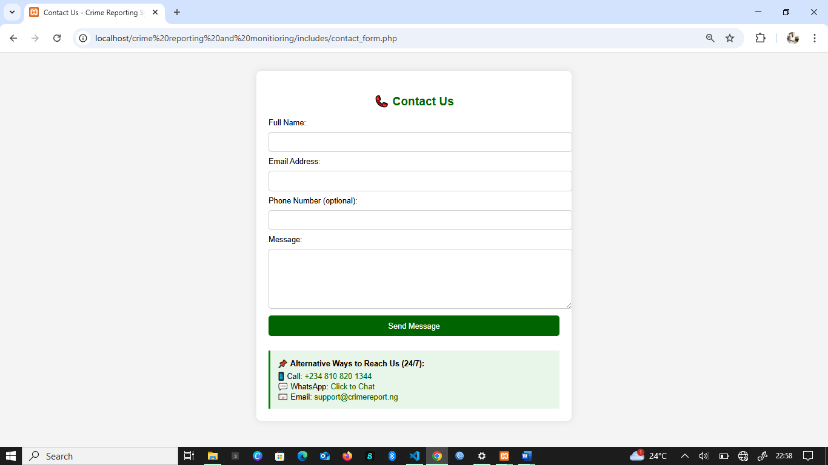
Fig 6.9 contact’s page

Appendix C
Section one
Reporting Habits
- Have you ever reported a crime to law enforcement?
  - Yes
  - No
- How frequently do you report crimes when they occur in your area?
  - Always
  - Often
  - Sometimes
  - Rarely
  - Never
- Do you believe that reporting crime makes a difference in your community?
  - True
  - False
Challenges in Crime Reporting
- Have you ever experienced challenges when trying to report a crime?
  - Yes
  - No
- Which of the following challenges have you faced when reporting a crime? (Select all that apply)
  - Delay in police response
  - Fear of retaliation
  - Lack of anonymity
  - Difficulty accessing reporting channels
  - Lack of feedback after reporting
  - Poor handling by officials
  - Others (please specify): ______________________
- I find the current crime reporting process efficient.
  - Strongly Agree
  - Agree
  - Neutral
  - Disagree
  - Strongly Disagree
Preferences and Anonymity
- Would you prefer to report crimes anonymously?
  - Yes
  - No
- I am more likely to report a crime if my identity is kept anonymous.
  - Strongly Agree
  - Agree
  - Neutral
  - Disagree
  - Strongly Disagree
Feedback and Follow-Up
- Feedback and follow-up after reporting a crime are important to me.
  - Strongly Agree
  - Agree
  - Neutral
  - Disagree
  - Strongly Disagree
- Have you ever received feedback after reporting a crime?
- Yes
- No
- The lack of follow-up discourages me from reporting future crimes.
- Strongly Agree
- Agree
- Neutral
- Disagree
- Strongly Disagree
General Opinions
- I believe crime monitoring systems should be accessible via mobile apps.
- Strongly Agree
- Agree
- Neutral
- Disagree
- Strongly Disagree
- I trust law enforcement to handle reported crimes confidentially.
- Strongly Agree
- Agree
- Neutral
- Disagree
- Strongly Disagree
- The introduction of a digital crime reporting system would improve the reporting process.
- Strongly Agree
- Agree
- Neutral
- Disagree
- Strongly Disagree
Section B
Question | Result Summary
Have you ever reported a crime? | 72% Yes, 28% No
How often do you report crimes? | 10% Always, 30% Often, 40% Sometimes, 15% Rarely, 5% Never
Do you believe reporting makes a difference? | 65% True, 35% False
Have you experienced challenges reporting? | 78% Yes, 22% No
Top challenges faced | 60% Fear of retaliation, 55% Delay in response, 45% Lack of anonymity, 30% Poor handling
Is current reporting efficient? | 12% Strongly Agree, 20% Agree, 25% Neutral, 28% Disagree, 15% Strongly Disagree
Prefer anonymous reporting? | 90% Yes, 10% No
More likely to report anonymously? | 75% Strongly Agree, 15% Agree, 5% Neutral, 3% Disagree, 2% Strongly Disagree
Is feedback important? | 80% Strongly Agree, 15% Agree, 3% Neutral, 1% Disagree, 1% Strongly Disagree
Have you ever received feedback? | 35% Yes, 65% No
Lack of follow-up discourages reporting | 60% Strongly Agree, 20% Agree, 10% Neutral, 5% Disagree, 5% Strongly Disagree
Should crime systems be mobile-based? | 70% Strongly Agree, 20% Agree, 5% Neutral, 3% Disagree, 2% Strongly Disagree
Trust law enforcement for confidentiality? | 30% Strongly Agree, 25% Agree, 20% Neutral, 15% Disagree, 10% Strongly Disagree
Digital systems improve reporting? | 65% Strongly Agree, 25% Agree, 5% Neutral, 3% Disagree, 2% Strongly Disagree
Section three interview
Interview Questions (for all respondents)
- How do people report crimes in your area of responsibility?
- How is crime information documented and monitored in your agency/community?
- Is the current system of crime reporting and monitoring effective? Why or why not?
- What are the major challenges you face with the current crime reporting system?
- What suggestions or improvements would you recommend for a modern web-based crime reporting and monitoring system?

Interview Responses (by personnel)
1. Chika Icheche
Rank/Role: Assistant Superintendent
Agency: Nigeria Immigration Service
Mode: Telephone
Response Summary:
- Reporting: People mostly report immigration-related crimes via hotlines or through physical visits to our office.
- Documentation: We use handwritten incident logs, later transcribed into a digital database.
- Effectiveness: Partially effective; delays occur due to manual processing.
- Challenges: Lack of real-time data sharing and under-reporting from border communities.
- Suggestions: A web-based portal that links immigration data with security networks across agencies would help trace suspects faster.
2. Uwakwe Chijioke Ogene
Role: Security Adviser to AE-FUNAI SUG
Agency: AE-FUNAI Student Union Government
Mode: Face-to-face
Response Summary:
- Reporting: Students report crimes to SUG or school security via phone calls or in-person.
- Documentation: We keep logbooks; however, not all cases reach the police or get properly followed up.
- Effectiveness: The current system is weak; most crimes go unreported.
- Challenges: Fear of victimization and lack of confidentiality discourages reporting.
- Suggestions: Introduce anonymous reporting via a mobile app and real-time notification to security personnel.
3. Nwinya Zobi
Rank/Role: Corporal
Agency: Nigerian Police Force
Mode: Face-to-face
Response Summary:
- Reporting: Citizens report through calls, direct visits, or patrol encounters.
- Documentation: Manually recorded in station diaries; entered into the police national database if serious.
- Effectiveness: The system works but is limited by logistics and personnel.
- Challenges: Poor infrastructure, lack of data integration, and delayed communication.
- Suggestions: A unified digital crime report platform that connects to NPF systems for real-time updates.
4. Igboji Osondu
Rank/Role: Chief Security
Agency: Inyimagu Ameka Vigilante Squad
Mode: Face-to-face
Response Summary:
- Reporting: Locals report crimes directly to our patrol team or at the community hall.
- Documentation: Verbal reports mostly; we keep some handwritten notes.
- Effectiveness: Not very effective due to lack of equipment and formal training.
- Challenges: No communication with official security agencies; we operate in isolation.
- Suggestions: Provide mobile tools for reporting, GPS tracking, and create a database that links us with police.
5. Edeke Desmond
Role: SA to Ebonyi State Governor on Internal Security (Ikwo LGA)
Agency: Ebonyi State Government
Mode: Face-to-face
Response Summary:
- Reporting: Reports come from community leaders, vigilantes, or through my direct phone line.
- Documentation: We receive verbal reports and forward written summaries to state security agencies.
- Effectiveness: It’s reactive rather than proactive. Lack of digital reporting weakens intelligence gathering.
- Challenges: Fragmented communication among stakeholders and inadequate database.
- Suggestions: A centralized system to collect, analyze, and escalate crime reports within local and state levels.
6. Nwigboji Ikechukwu Kingsely
Rank/Role: Flying Officer
Agency: Nigerian Air Force (NAF)
Mode: Social Media Chat
Response Summary:
- Reporting: Most reports we handle are intelligence-based or come from other agencies.
- Documentation: Strict internal systems handle reports, but public crime reporting isn’t direct to us.
- Effectiveness: For military-related crimes, it’s structured; but public integration is poor.
- Challenges: Civilian-military information flow is weak.
- Suggestions: Web-based systems should integrate secure military access points for threat assessments.
- Mkpatanku Basili
Rank/Role: Lieutenant
Agency: Nigerian Army
Mode: Telephone
Response Summary:
- Reporting: Reports are usually passed through civilian informants or forwarded by police.
- Documentation: Structured logs are kept, but not open to public systems.
- Effectiveness: Effective internally, but limited civilian interface.
- Challenges: Coordination gap between military and civilian security systems.
- Suggestions: Establish a reporting platform with layers of access for civilians, police, and the military.

